**Eatonomy**



**Project ID: Fall-2023-51**

**Session: BSCS Fall 2020 to 2024**

**Project Advisor: Mr. Abdul Ghaffar**

**Submitted By**

|  |  |
| --- | --- |
| Haider Ali | 70069779 |
| Muhammad Ali | 70109014 |
|  |  |
|  |  |



Department of Computer Science & IT

The University of Lahore

Lahore, Pakistan

## *Declaration*

We have read the project guidelines and we understand the meaning of academic dishonesty, in particular plagiarism and collusion. We hereby declare that the work we submitted for our final year project, entitled **Eatonomy** is original work and has not been printed, published, or submitted before as a final year project, research work, publication, or any other documentation.

## 

**Group Member 1 Name:** Haider Ali

**SAP No: 70069779**

**Signature: …………………………**

**Group Member 2 Name: Muhammad Ali**

**SAP No: 70109014**

**Signature: …………………………**

## *Statement of Submission*

This is to certify that **Haider Ali** Roll No. **70069779 and Muhammad Ali** Roll No. **70109014 have** successfully submitted the final project named **Eatonomy**, at the Computer Science & IT Department, The University of Lahore, Lahore, Pakistan, to fulfill the partial requirement of the degree of **BS in Computer Science**.

**Supervisor Name: Mr. Abdul Ghaffar**

**Signature: …………………………**

**Date: ………………………**

## 

## *Dedication*

This project is dedicated to our fathers, who taught each of us that the best kind of knowledge to have is that which is learned for its own sake. It is also dedicated to our mothers, who taught us that even the largest task can be accomplished if it is done one step at a time.

## *Acknowledgment*

## 

We truly acknowledge the cooperation and help made by Name of **Mr. Abdul Ghaffar**, **Professor** of the **University of Lahore**. He has been a constant source of guidance throughout the course of this project. We are also thankful to our friends and families whose silent support led us to complete our project.

Date:

October 22, 2023

## *Abstract*

This project focuses on the issues that are yet to be resolved by other food delivery apps, such as giving food recommendations when the user is unable to decide, be it alone or within a group. This app will also give users healthier options so that they can enjoy a balanced diet.

Our project involves the development of mobile applications for both iOS and Android platforms using the Flutter framework, which is enriched with artificial intelligence capabilities to enhance the user experience and provide intelligent features.

***Technologies used***

* Flutter
* Firebase
* Google maps

## List of Figures

*Figure 0.1 Example of User Interface* 3

*Figure 1.1 Usecase Diagram - User* 19

*Figure 1.2 Usecase Diagram - Admin / Restaurant* 32

*Figure 2 Architecture Diagram* 37

*Figure 3 ERD* 39

*Figure 4 Level 0 DFD* 39

*Figure 5 Level 1 DFD* 40

*Figure 6 Class Diagram* 41

*Figure 7.1 Activity diagram Create Account* 42

*Figure 7.2 Activity Diagram Login Account* 43

*Figure 7.3 Activity Diagram Forgot password* 44

*Figure 7.4 Activity Diagram Food Recommendation* 45

*Figure 7.5 Activity Diagram Account Management* 46

*Figure 7.6 Activity Diagram View Restaurant* 47

*Figure 7.7 Activity Diagram View Cart* 48

*Figure 7.8 Activity Diagram Restaurant Login* 49

*Figure 7.9 Activity Diagram Restaurant Account Management* 50

*Figure 7.10 Activity Diagram Restaurant Edit Details* 51

*Figure 7.11 Activity Diagram Restaurant Dashboard* 52

*Figure 7.12 Activity Diagram Edit Restaurant Menu* 53

*Figure 7.13 Activity Diagram Restaurant Sales* 54

*Figure 7.14 Activity Diagram Restaurants incoming orders* 55

*Figure 7.15 Activity Diagram Pending Orders* 56

*Figure 7.16 Activity Diagram Customer Complaints/Feedback* 57

*Figure 7.17 Activity Diagram Completed Orders* 58

*Figure 7.18 Activity Diagram Refunds* 59

*Figure 8.1 Sequence Diagram Create Account* 60

*Figure 8.2 Sequence Diagram Login Account* 61

*Figure 8.3 Sequence Diagram Forgot Password* 62

*Figure 8.4 Sequence Diagram Food Recommendation* 63

*Figure 8.5 Sequence Diagram manage account* 64

*Figure 8.6 Sequence Diagram View Restaurants* 65

*Figure 8.7 Sequence Diagram View Cart* 66

*Figure 8.8 Sequence Diagram Restaurant Login* 67

*Figure 8.9 Sequence Diagram Restaurant Dashboard* 68

*Figure 8.10 Sequence Diagram Restaurant Manage Account* 69

*Figure 8.11 Sequence Diagram Edit Restaurant Details* 70

*Figure 8.12 Sequence Diagram Edit Restaurant Menu* 71

*Figure 8.13 Sequence Diagram Restaurant Sales* 72

*Figure 8.14 Sequence Diagram Restaurant Incoming Orders* 73

*Figure 8.15 Sequence Diagram Restaurant Pending Orders* 74

*Figure 8.16 Sequence Diagram Restaurant Customer Complaints/Feedback* 75

*Figure 8.17 Sequence Diagram Restaurant Completed Orders* 76

*Figure 8.18 Sequence Diagram Restaurant Refunds* 77

*Figure 9 Collaboration Diagram* 78

*Figure 10 State Transition Diagram* 79

*Figure 11 Component Diagram* 80

*Figure 12 Deployment Diagram* 81

*Figure 13.1 Login Screen* 88

*Figure 13.2 Sign up Screen* 90

*Figure 13.3 Preferences Screen* 91

*Figure 13.4 Eatonomy Hub* 92

*Figure 13.5 Restaurant Overview* 93

*Figure 13.6 View Cart* 94

*Figure 13.7 Favorites Hub* 95

## List of Tables

*Table 1.1: Functional Requirements - Register* 5

*Table 1.2: Functional Requirements - Login* 6

*Table 1.3: Functional Requirements – Forget Password* 7

*Table 1.4: Functional Requirements – Reset Password* 8

*Table 1.5: Functional Requirements – Manage Account* 9

*Table 1.6: Functional Requirements – Food preferences* 9

*Table 1.7: Functional Requirements – View Restaurants* 10

*Table 1.8: Functional Requirements - Search* 11

*Table 1.9: Functional Requirements – Restaurant Details* 12

*Table 1.10: Functional Requirements – Food categories* 13

*Table 1.11: Functional Requirements – Popular Items* 13

*Table 1.12: Functional Requirements – View Cart* 14

*Table 1.13: Functional Requirements – View Favorites* 15

*Table 1.14: Functional Requirements – Order History* 16

*Table 1.15: Functional Requirements - Payment* 17

*Table 2.1: Use Case – Customer Sign Up* 20

*Table 2.2: Use Case – Customer Login* 20

*Table 2.3: Use Case – Customer Manage Account* 21

*Table 2.4: Use Case – Customer Edit Address* 21

*Table 2.5: Use Case – Customer Add Address* 21

*Table 2.6: Use Case – Customer Remove Address* 22

*Table 2.7: Use Case – Customer Change Password* 22

*Table 2.8: Use Case – Customer Edit Phone Number* 23

*Table 2.9: Use Case – Customer Add Phone Number* 23

*Table 2.10: Use Case – Customer Remove Phone Number* 24

*Table 2.11: Use Case – Customer Edit Picture* 24

*Table 2.12: Use Case – Customer Change Name* 24

*Table 2.13: Use Case – Customer View Restaurants* 25

*Table 2.14: Use Case – Customer View Restaurant Details* 25

*Table 2.15: Use Case – Customer View Restaurant Menu* 26

*Table 2.16: Use Case – Customer View Food Recommendations* 26

*Table 2.17: Use Case – Customer View Preferred Restaurants* 27

*Table 2.18: Use Case – Customer View Preferred Restaurant Menu* 27

*Table 2.19: Use Case – Customer View Cart* 28

*Table 2.20: Use Case – Customer Remove Item from Cart* 28

*Table 2.21: Use Case – Customer Place Order* 29

*Table 2.22: Use Case – Customer Payment* 29

*Table 2.23: Use Case – Customer Confirm Order* 29

*Table 2.24: Use Case – Customer View Favorites* 30

*Table 2.25: Use Case – Customer Order History* 30

*Table 2.26: Use Case – Customer Payment Method* 31

*Table 2.27: Use Case – Restaurant Login* 33

*Table 2.28: Use Case – Restaurant Manage Account* 33

*Table 2.29: Use Case – Restaurant Dashboard* 33

*Table 2.30: Use Case – Restaurant Edit Restaurant Details* 34

*Table 2.31: Use Case – Restaurant Edit Restaurant Menu* 34

*Table 2.32: Use Case – Restaurant Sales* 35

*Table 2.33: Use Case – Restaurant Incoming Orders* 35

*Table 2.34: Use Case – Restaurant Pending Orders* 35

*Table 2.35: Use Case – Restaurant Customer Complaints/Feedback* 36

*Table 2.36: Use Case – Restaurant Completed Orders* 36

*Table 2.37: Use Case – Restaurant Refunds* 37

**Table of Content**

*Declaration* i

*Statement of Submission* ii

*Dedication* iii

*Acknowledgment* iv

*Abstract* v

List of Figures vi

List of Tables viii

Chapter 1: Introduction to the Problem 1

1.1 Introduction 1

1.2 Purpose 1

1.3 Objective 1

1.4 Existing Solution 1

1.5 Proposed Solution 1

Chapter 2: Software Requirement Specification 2

2.1 Introduction 2

2.1.1 Purpose 2

2.1.2 Scope 2

2.1.3 Definitions, acronyms, and abbreviations 2

2.2 Overall description 2

2.2.1 Product perspective 2

2.2.2 Product functions 4

*Table 1.1: Functional Requirements - Register* 5

*Table 1.2: Functional Requirements - Login* 6

*Table 1.3: Functional Requirements – Forget Password* 7

*Table 1.4: Functional Requirements – Reset Password* 8

*Table 1.5: Functional Requirements – Manage Account* 9

*Table 1.6: Functional Requirements – Food preferences* 9

*Table 1.7: Functional Requirements – View Restaurants* 10

*Table 1.8: Functional Requirements - Search* 11

*Table 1.9: Functional Requirements – Restaurant Details* 12

*Table 1.10: Functional Requirements – Food categories* 13

*Table 1.11: Functional Requirements – Popular Items* 13

*Table 1.12: Functional Requirements – View Cart* 14

*Table 1.13: Functional Requirements – View Favorites* 15

*Table 1.14: Functional Requirements – Order History* 16

*Table 1.15: Functional Requirements - Payment* 17

2.2.3 User characteristics 17

2.2.4 Constraints 17

2.2.5 Assumptions and dependencies 17

2.2.6 Apportioning of Requirements 17

2.3 Specific requirements 18

2.3.1 Functional Requirement 18

2.3.2 Non-functional Requirements 18

Chapter 3: Use Case Analysis 19

*Table 2.1: Use Case – Customer Sign Up* 20

*Table 2.2: Use Case – Customer Login* 20

*Table 2.3: Use Case – Customer Manage Account* 21

*Table 2.4: Use Case – Customer Edit Address* 21

*Table 2.5: Use Case – Customer Add Address* 21

*Table 2.6: Use Case – Customer Remove Address* 22

*Table 2.7: Use Case – Customer Change Password* 22

*Table 2.8: Use Case – Customer Edit Phone Number* 23

*Table 2.9: Use Case – Customer Add Phone Number* 23

*Table 2.10: Use Case – Customer Remove Phone Number* 24

*Table 2.11: Use Case – Customer Edit Picture* 24

*Table 2.12: Use Case – Customer Change Name* 24

*Table 2.13: Use Case – Customer View Restaurants* 25

*Table 2.14: Use Case – Customer View Restaurant Details* 25

*Table 2.15: Use Case – Customer View Restaurant Menu* 26

*Table 2.16: Use Case – Customer View Food Recommendations* 26

*Table 2.17: Use Case – Customer View Preferred Restaurants* 27

*Table 2.18: Use Case – Customer View Preferred Restaurant Menu* 27

*Table 2.19: Use Case – Customer View Cart* 28

*Table 2.20: Use Case – Customer Remove Item from Cart* 28

*Table 2.21: Use Case – Customer Place Order* 29

*Table 2.22: Use Case – Customer Payment* 29

*Table 2.23: Use Case – Customer Confirm Order* 29

*Table 2.24: Use Case – Customer View Favorites* 30

*Table 2.25: Use Case – Customer Order History* 30

*Table 2.26: Use Case – Customer Payment Method* 31

*Table 2.27: Use Case – Restaurant Login* 33

*Table 2.28: Use Case – Restaurant Manage Account* 33

*Table 2.29: Use Case – Restaurant Dashboard* 33

*Table 2.30: Use Case – Restaurant Edit Restaurant Details* 34

*Table 2.31: Use Case – Restaurant Edit Restaurant Menu* 34

*Table 2.32: Use Case – Restaurant Sales* 35

*Table 2.33: Use Case – Restaurant Incoming Orders* 35

*Table 2.34: Use Case – Restaurant Pending Orders* 35

*Table 2.35: Use Case – Restaurant Customer Complaints/Feedback* 36

*Table 2.36: Use Case – Restaurant Completed Orders* 36

*Table 2.37: Use Case – Restaurant Refunds* 37

Chapter 4: Design 37

4.1 Architecture Diagram 37

4.2 ERD with data dictionary 38

4.3 Data Flow diagram 39

4.3.1 The level 0 39

4.3.1 The level 1 40

4.4 Class Diagram 41

4.5 Activity Diagram 42

4.5.1 Activity diagram for create account 42

4.5.2 Activity diagram for login account 43

4.5.3 Activity diagram for forgot password. 44

4.5.4 Activity diagram for Food Recommendation 45

4.5.5 Activity diagram for account management 46

4.5.6 Activity diagram for View Restaurant 47

4.5.7 Activity diagram for View Cart 48

4.5.8 Activity diagram for Restaurant Login 49

4.5.9 Activity diagram for Restaurant account management 50

4.5.10 Activity diagram for Restaurant Edit Details 51

4.5.11 Activity diagram for Restaurant Dashboard 52

4.5.12 Activity diagram for Edit Restaurant Menu 53

4.5.13 Activity diagram for Restaurant Sales 54

4.5.14 Activity diagram for Restaurants incoming orders 55

4.5.15 Activity diagram for Pending Orders 56

4.5.16 Activity diagram for Customer Complaints/Feedback 57

4.5.17 Activity diagram for Completed Orders 58

4.5.18 Activity diagram for Refunds 59

4.6 Sequence Diagram 60

4.6.1 Sequence diagram for create account 60

4.6.2 Sequence diagram for Login account 61

4.6.3 Sequence diagram for Forgot password 62

4.6.4 Sequence diagram for Food Recommender 63

4.6.5 Sequence diagram for manage account 64

4.6.6 Sequence diagram for View Restaurants 65

4.6.7 Sequence diagram for View Cart 66

4.6.8 Sequence diagram for Restaurant Login 67

4.6.9 Sequence diagram for Restaurant Dashboard 68

4.6.10 Sequence diagram for Restaurant Manage Account 69

4.6.11 Sequence diagram for Edit Restaurant Details 70

4.6.12 Sequence diagram for Edit Restaurant Menu 71

4.6.13 Sequence diagram for Restaurant Sales 72

4.6.14 Sequence diagram for Restaurant Incoming Orders 73

4.6.15 Sequence diagram for Restaurant Pending Orders 74

4.6.16 Sequence diagram for Restaurant Customer Complaints/Feedback 75

4.6.17 Sequence diagram for Restaurant Completed Orders 76

4.6.18 Sequence diagram for Restaurant Refunds 77

4.7 Collaboration Diagram 78

4.8 State Transition Diagram 79

4.9 Component Diagram 80

4.10 Deployment Diagram 81

Chapter 8: User Manual 88

8.1 Sign Up Screen 88

8.2 Log in Interface 90

8.3 Preferences Hub 91

8.4 Eatonomy Hub 92

8.5 Restaurant Profile 93

8.6 View Cart 94

8.7 Favorites Hub 95

References 96

Appendix 97

### 

### Chapter 1: Introduction to the Problem

##### Introduction

Whenever we go out to eat, we normally take a lot of time to decide what we want to eat and from what restaurant we want to eat, and we are also restricted by our budget as well. However, there is no app that can provide personalized and optimal food suggestions based on these factors and the user’s order history. We end up wasting a lot of time in thinking about what to order and may even end up choosing something that is not near us or even miss out on many options that do not come into our minds.

##### Purpose

Many factors affect our ability to select what food we want to eat. Our mood, different varieties of cuisine, and the budget that we can spend all affect our decisions about what we want to eat. This app helps us make our lives easier and saves us a lot of time in deciding what to eat by offering us the best suggestions based on our previous order history as well as asking for what we might be interested in eating and giving us a personalized menu even if we have a group of more than one person.

##### Objective

Our objective for this app is to develop a user-friendly interface that allows users to input their dietary preferences and location. Our app will use an algorithm that analyzes user data and recommends appropriate food choices from local restaurants. The app will have a comprehensive restaurant database to provide a wide range of food options to users. Data privacy and security will be ensured by adhering to relevant regulations and implementing robust security measures. We want to achieve a high level of user satisfaction and engagement with the app, leading to increased usage and user retention.

##### Existing Solution

None of our competitors have a viable solution that aids the user while ordering food. They just have a basic recommendations section that is mostly based on what other people might be ordering. Or they just display the sponsored menu items. These may not even be relevant to each individual user or what the user might want.

##### Proposed Solution

Our solution to help with the food recommendation problem revolves around utilizing Artificial Intelligence and machine learning to help making the decision making process easier. We will be analyzing user preferences, historical choices, and real-time trends. User profiles will play a pivotal role, allowing individuals to specify dietary preferences, preferred cuisines, and ambiance choices. By prioritizing user privacy, employing advanced recommendation technology, and incorporating real-time updates, Eatonomy aims to be the forefront of the culinary exploration, setting a new standard for tailored food discovery."

### Chapter 2: Software Requirement Specification

##### Introduction

##### Purpose

This document's objective is to give a comprehensive overview of our software product, including its specifications and objectives. As this will outline what the developers must accomplish and the final product we hope to deliver, the invigilators, project advisers, and project leaders are the target audiences. This research project will aid future students in their research projects by compiling all the relevant data in one place. In an effort to improve knowledge and data gathering, we are working.

##### Scope

The project involves the development of a food recommender application for iOS and Android platforms. It will enable users to specify their culinary preferences, dietary restrictions, and the context of their dining occasions. The application, enhanced by artificial intelligence, will intelligently curate restaurant and menu recommendations that align with individual tastes. Eatonomy's primary aim is to deliver a tailored and user-friendly food ordering experience while promoting local restaurant growth. This scope aligns with the overarching project vision and maintains consistency with higher-level system requirements for a strategic and coherent development approach.

##### Definitions, acronyms, and abbreviations

Acronyms: App- Application

##### Overall description

##### Product perspective

* **System interfaces**: The Eatonomy app interfaces with a variety of systems to provide a seamless user experience. It connects with iOS and Android platforms, interacts with an artificial intelligence engine for personalized recommendations, accesses a restaurant database for up-to-date menu information, and integrates with payment gateways for secure transactions. The app also utilizes GPS and location services, user profile databases, and push notification services to enhance user engagement. These interfaces work in concert to deliver a tailored and efficient food-ordering solution to our users.

**User interfaces: (define the layout of the user end including the screenshots)** 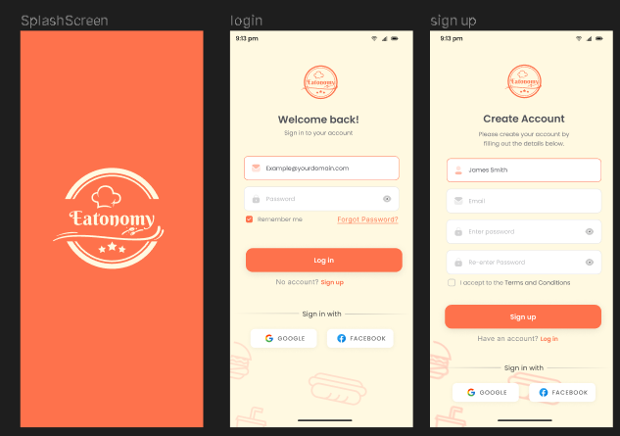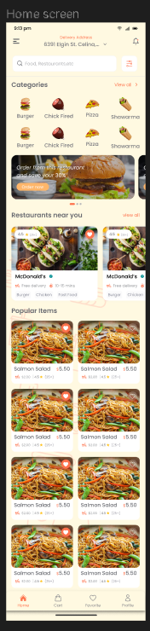 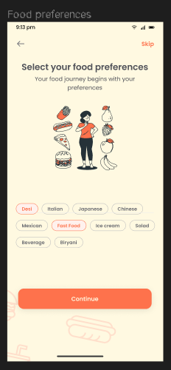 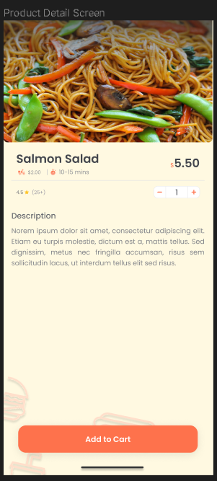

###### *Figure 0.1 Example of User Interface*

* **Hardware interfaces:** Eatonomy interfaces with mobile devices on both iOS and Android platforms, utilizing hardware features such as GPS for location-based recommendations and network connectivity for data communication.
* **Software interfaces:** The device needs to have an internet connection and should have sufficient storage to download the app.
* **Communications interfaces:** Communication interfaces in the app ensures secure data transmission via HTTPS for order placement, profile updates, and recommendation retrieval. Users are required to have a valid Gmail ID for authentication. The interfaces support real-time order management, partnerships with local restaurants and delivery services, secure payment processing, and user notifications.
* **Memory:** The app is at least 100 MB in size, which includes executable code, resources, and data. Memory management is optimized to work within the constraints of a user's device, efficiently utilizing both primary (RAM) and secondary memory (storage) resources to provide a smooth user experience.
* **Operations:** For data backup and recovery in our app, user-specific data, including preferences, order history, and other relevant information, is stored in a secure database associated with the user's Gmail account. This approach ensures data integrity and allows for seamless recovery in the event of data loss or system failures.
* **Site adaptation requirements:** As of the current version, Eatonomy does not include any site adaptations; however, it remains open to the possibility of incorporating such features in future iterations

##### Product functions

Product functions include the functional requirement of your project

Now what is the functional requirements suppose you have a module of Account

Registration in your project then the functional requirement for this module are Create Account, View Account, Delete Account, Update Account, Login Account, Logout Account, etc. and many more according to the situation you are in.

The following things are included in each of the functional requirement of your project

* ID
* Name
* Description
* Input
* Output
* Basic Work Flow
* Requirements (optional)

For example, you create account functional requirement look like this and you have to follow this template for writing your functional requirements

|  |  |  |  |  |
| --- | --- | --- | --- | --- |
| ID: | **FR_01** |  |  |  |
| Name: | Register |  |  |  |
| Description | Input | Output | Requirements | Basic Work Flow |
| This functionality enables users to create an account by entering accurate details. | **User Details (e.g., Name, Email, Password):** Muhammad Ali, 70109014@gmail.com, 12345 | **Account Creation Confirmation:** Confirmation message indicating the successful creation of the account. | **Internet Connectivity:** Essential for user interaction and communication with the server.  **Database Integration:** System must save user records in the database. | Muhammad Ali initiates the registration process by entering accurate details—name, email (70109014@gmail.com), and password (12345). With internet connectivity, he submits the information, prompting the system to validate the data and subsequently create a new user record in the database. A confirmation message is relayed to Muhammad Ali, acknowledging the successful account creation. If desired, he can immediately log in using the newly established credentials. The workflow prioritizes user guidance and error handling, ensuring a seamless and professional registration experience. |

##### *Table 1.1: Functional Requirements - Register*

|  |  |  |  |  |
| --- | --- | --- | --- | --- |
| ID: | **FR_02** |  |  |  |
| Name: | Login |  |  |  |
| Description | Input | Output | Requirements | Basic Work Flow |
| This feature facilitates user access by allowing them to log in with their registered credentials. | **User Credentials (e.g., Email, Password):** 70109014@gmail.com, 12345 | **Login Approval:** Confirmation of successful login. | **Internet Connectivity:** Necessary for user interaction and communication with the server.  **Existing User Data:** The system should have previously saved user data for authentication. | Upon entering correct login information, such as email (70109014@gmail.com) and password (12345), the system authenticates the data. If successful, access is granted with a confirmation of login approval, redirecting the user to their dashboard. In case the entered data is not found, the system prompts the user to sign up for an account, ensuring a seamless and secure login experience. |

##### *Table 1.2: Functional Requirements - Login*

|  |  |  |  |  |
| --- | --- | --- | --- | --- |
| ID: | **FR_03** |  |  |  |
| Name: | Forget Password |  |  |  |
| Description | Input | Output | Requirements | Basic Work Flow |
| This feature allows users to recover their forgotten passwords. | **User Identifier (e.g., email, username):** The information used to identify the user account.  Security **Verification (e.g., CAPTCHA, security questions):** To ensure the request is legitimate.  **New Password:** The desired new password for the user account. | **Success/Failure Message:** Confirmation that the password has been successfully reset or an error message if unsuccessful. | **Internet Connectivity required:**  Required for user interaction and communication with the server. | The **"Forget Password"** workflow begins when a user, unable to remember their password, clicks on the associated link. After providing their account identifier and passing security verification, a unique token or link is generated and sent to the user. Upon clicking the link, the user accesses a secure page to set a new password. Once the password is updated, the system confirms the change, and the user receives a success message. Error handling is integrated at each step to guide the user in case of issues, ensuring a smooth and secure forget password process. |

##### *Table 1.3: Functional Requirements – Forget Password*

|  |  |  |  |  |
| --- | --- | --- | --- | --- |
| ID: | **FR_04** |  |  |  |
| Name: | Reset Password |  |  |  |
| Description | Input | Output | Requirements | Basic Work Flow |
| This feature allows users to securely reset their password in the event of forgetting or needing to update it. | **User Identifier (e.g., Email):** User provides the identifier associated with their account.  Security **Verification (e.g., CAPTCHA, Security Questions):** Ensures the legitimacy of the password reset request.  **New Password:** The desired new password for the user account. | **Reset Confirmation:** Confirmation message indicating the successful reset of the password. | **Internet Connectivity required:**  Required for user interaction and communication with the server. | The **Reset Password** workflow commences when users click the "Reset Password" link on the login page and provide their account identifier. After completing security verification measures, a unique token or link is generated and sent to the user. By clicking on this link, users gain access to a secure interface to set a new password, and upon confirmation, the system updates their password, concluding the process with a success message. This straightforward and secure workflow ensures a seamless experience for users seeking to reset their passwords. |

##### *Table 1.4: Functional Requirements – Reset Password*

|  |  |  |  |  |
| --- | --- | --- | --- | --- |
| ID: | **FR_05** |  |  |  |
| Name: | Manage Account |  |  |  |
| Description | Input | Output | Requirements | Basic Work Flow |
| This functionality empowers users to maintain and update their profile details, including picture, name, phone number, address, and password. | **Function: Change Name**  New Name: Haider  **Function: Change Password**  New Password: 786786  **Function: Change Address**  New Address: Wapda Town | **Profile Modification Confirmation:**  Confirmation message indicating successful changes to the profile. | **Internet Connectivity:** Necessary for user interaction and communication with the server.  **Existing User Data:** The system should have previously saved user data for modification. | In the Manage Account workflow, users select the desired function (Change Name, Change Password, Change Address) and input new information. After clicking Submit, the system validates the data and updates the user's profile in the database. A confirmation message is then delivered, and the modified details are immediately reflected in the user's profile, with robust error handling in place for any potential issues during the process. |

##### *Table 1.5: Functional Requirements – Manage Account*

|  |  |  |  |  |
| --- | --- | --- | --- | --- |
| ID: | **FR_06** |  |  |  |
| Name: | Food Preferences |  |  |  |
| Description | Input | Output | Requirements | Basic Work Flow |
| This feature allows users to narrow down restaurant options based on their food preferences. | **User Food Preferences:**  Preferences: Fast Food, Italian, and Desi | **Filtered Restaurant List:** A list of restaurants that match the user's selected food preferences. | **Internet Connectivity:** Necessary for user interaction and communication with the server. | To utilize the Food Preferences feature, users launch the Android application, log in with their official account credentials, and navigate to the preferences screen. Once there, users can select their food preferences, such as Fast Food, Italian, and Desi, to refine restaurant recommendations. The application then filters and presents a list of restaurants tailored to the chosen criteria, ensuring personalized dining options aligned with the user's taste preferences. |

##### *Table 1.6: Functional Requirements – Food preferences*

|  |  |  |  |  |
| --- | --- | --- | --- | --- |
| ID: | **FR_07** |  |  |  |
| Name: | View Restaurants |  |  |  |
| Description | Input | Output | Requirements | Basic Work Flow |
| This feature provides users with a curated list of restaurants based on their location and ratings, enhancing the dining experience. | User Action:  Function: View Restaurants  Restaurants: KFC, Gloria Jeans, etc. | List of Restaurants: Displayed with detailed information, including ratings and operating hours. | Internet Connectivity: Essential for user interaction and real-time retrieval of restaurant data.  Restaurant Availability: The functionality relies on up-to-date and available restaurant information. | To access the View Restaurants feature, users launch the Android application, authenticate using official account credentials, and navigate to the preferences screen. Subsequently, users can choose to skip the selection process, prompting the application to present a comprehensive list of available restaurants meticulously shortlisted based on location and ratings. This approach ensures that users are presented with pertinent dining options, complete with essential details like ratings and operating hours, fostering an informed and personalized restaurant selection experience. |

##### *Table 1.7: Functional Requirements – View Restaurants*

|  |  |  |  |  |
| --- | --- | --- | --- | --- |
| ID: | **FR_08** |  |  |  |
| Name: | Search for Restaurant and Food Items |  |  |  |
| Description | Input | Output | Requirements | Basic Work Flow |
| This feature allows users to search for specific restaurants and food items, enhancing the browsing and selection experience. | **Search Query:** Users input keywords related to restaurant names or specific food items. | **Search Results:** Displayed in a list format, including relevant restaurants and food items matching the search query. | Internet Connectivity: Essential for real-time retrieval of search results. | Users initiate the "Search for Restaurant and Food Items" feature by entering relevant keywords into the search bar. The system processes the query, retrieves matching results from the database, and displays a list of restaurants and food items meeting the specified criteria. Users can seamlessly explore and select options from the search results, providing an efficient and tailored experience for discovering preferred dining choices within the application. |

##### *Table 1.8: Functional Requirements - Search*

|  |  |  |  |  |
| --- | --- | --- | --- | --- |
| ID: | **FR_09** |  |  |  |
| Name: | Restaurant Profile |  |  |  |
| Description | Input | Output | Requirements | Basic Work Flow |
| This feature provides users with comprehensive information about a specific restaurant, including its name, menu, availability, rating, and reviews. | **Function:** View Restaurant Profile  Restaurant **Identifier**: Unique identifier for the desired restaurant | **Restaurant Details:** Displayed information about the restaurant, including name, menu, availability, rating, and reviews. | **Internet Connectivity:** Necessary for real-time retrieval of restaurant profile data. | Users access the "Restaurant Profile" feature by selecting a specific restaurant or entering its unique identifier. The system processes the request, retrieving and prominently displaying essential details such as the restaurant's name, menu items, availability status, overall rating, and customer reviews. This streamlined workflow empowers users to make informed dining decisions by providing comprehensive insights into a chosen restaurant's offerings and reputation. |

##### *Table 1.9: Functional Requirements – Restaurant Details*

|  |  |  |  |  |
| --- | --- | --- | --- | --- |
| ID: | **FR_10** |  |  |  |
| Name: | Food Categories |  |  |  |
| Description | Input | Output | Requirements | Basic Work Flow |
| This feature categorizes restaurants and food items, allowing users to explore specific types of cuisine. | **Category Selection:** Users choose a specific category, such as Burger, Pizza, Shawarma, etc. | **Category Contents:** Displayed list of restaurants and food items falling under the selected category. | Internet Connectivity: Necessary for real-time retrieval of category-specific data. | Users access the "Categories" feature by selecting a specific category, such as Burger, Pizza, or Shawarma. The system then retrieves and displays a list of restaurants and food items falling under the chosen category, enabling users to seamlessly explore and select options within their preferred cuisine. This straightforward workflow streamlines the user experience, facilitating efficient navigation and discovery of dining choices based on specific categories. |

##### *Table 1.10: Functional Requirements – Food categories*

|  |  |  |  |  |
| --- | --- | --- | --- | --- |
| ID: | **FR_11** |  |  |  |
| Name: | Popular Items |  |  |  |
| Description | Input | Output | Requirements | Basic Work Flow |
| This feature showcases a curated list of popular food items based on user preferences and ratings. | **User Preferences:** The system considers individual user preferences and historical ordering data. | **Popular Items Display:** A dynamic list of food items popular among users, accompanied by ratings and recommendations | **Internet Connectivity:** Essential for real-time retrieval and updating of popular item data. | The "Popular Items" feature leverages user preferences and historical data to compile a dynamic list of highly-rated and frequently chosen food items. Users are presented with this curated selection, allowing them to explore and select popular dishes directly, enhancing their ordering experience with recommendations that align with broader preferences. The system continuously updates popular items based on real-time user feedback, ensuring the displayed choices remain relevant and reflective of current user preferences. |

##### *Table 1.11: Functional Requirements – Popular Items*

|  |  |  |  |  |
| --- | --- | --- | --- | --- |
| ID: | **FR_12** |  |  |  |
| Name: | View Cart |  |  |  |
| Description | Input | Output | Requirements | Basic Work Flow |
| This feature enables users to review their selected items in the cart along with the total amount, providing a transparent overview of their order. | **User Action:**  **Function: View Cart**  Cart: Burger, Pizza, Naan Chana | **Selected Items in Cart:** Displayed with individual prices and a prominently featured total amount. | **Internet Connectivity:** Essential for user interaction and real-time retrieval of cart data. | By clicking the dedicated cart icon, users can seamlessly examine the contents of their cart, revealing a comprehensive list of the items they have chosen, including Burger, Pizza, and Naan Chana. Each food item is associated with its respective price, and for a thorough overview, the total cost of all selected items is prominently displayed. This approach ensures users have a clear and detailed summary of their order, facilitating a more informed decision-making process. |

##### *Table 1.12: Functional Requirements – View Cart*

|  |  |  |  |  |
| --- | --- | --- | --- | --- |
| ID: | **FR_13** |  |  |  |
| Name: | View Favorites |  |  |  |
| Description | Input | Output | Requirements | Basic Work Flow |
| This feature allows users to access and view their favorite restaurants and items for a personalized and efficient ordering experience. | **User Action:**  **Function:** View Favorites | **Favorite Restaurants and Items:** Displayed with relevant details, such as restaurant names and favorite food items. | **Internet Connectivity:** Essential for user interaction and real-time retrieval of favorite data. | By selecting the View Favorites function, users can conveniently access a curated list of their favorite restaurants and items. This personalized view includes pertinent details such as restaurant names and specific favorite food items. This feature aims to streamline the ordering process for users, offering quick access to their preferred choices for a more tailored and enjoyable dining experience. |

##### *Table 1.13: Functional Requirements – View Favorites*

|  |  |  |  |  |
| --- | --- | --- | --- | --- |
| ID: | **FR_14** |  |  |  |
| Name: | Order History |  |  |  |
| Description | Input | Output | Requirements | Basic Work Flow |
| This feature allows users to access and view both their current and previous orders, providing a comprehensive overview of their order history. | **User Action:**  **Function:** View Order History | **Order Details:** Displayed in a list format, including information on current and completed orders. | **Internet Connectivity:**  Essential for real-time retrieval and display of order history. | Users access the "Order History" feature to review both current and completed orders. The system retrieves and displays relevant details, allowing users to explore their current orders' status and revisit information on previous transactions for a comprehensive overview of their ordering history. |

##### *Table 1.14: Functional Requirements – Order History*

|  |  |  |  |  |
| --- | --- | --- | --- | --- |
| ID: | **FR_15** |  |  |  |
| Name: | Payment Method - Cash on Delivery (COD) |  |  |  |
| Description | Input | Output | Requirements | Basic Work Flow |
| This feature allows users to make payments for their orders using the Cash on Delivery (COD) method. | **User Selection:**  **Function:** Select Payment Method  **Payment Method:** Cash on Delivery | **Payment Confirmation:**  Confirmation message acknowledging the selection of Cash on Delivery as the payment method. | **Internet Connectivity:**  Necessary for the user to interact with the application and confirm the payment method. | Users select the "Payment Method" during the checkout process and specifically opt for Cash on Delivery. The system confirms the selection with a message, and upon order completion, users pay in cash upon the delivery of their items. This streamlined workflow ensures a seamless and user-friendly experience for customers choosing the Cash on Delivery payment method. |

##### *Table 1.15: Functional Requirements - Payment*

##### User characteristics

Users of this app are individuals who want it to suggest the best local restaurants for them and their families based on their cuisine preferences.

##### Constraints

Our food app Eatonomy faces hardware and usability limitations, supporting newer Android versions only. While the initial interface might seem unfamiliar, it's designed for a user-friendly experience. Seamless app integration with other apps is a work in progress, and location control is available for preferences. Two-factor authentication and password encryption will be added for enhanced security, and regulatory compliance is a top priority.

##### Assumptions and dependencies

Within the framework of our app, we operate under the assumption that essential shop-related details, including the shop's name, menu, and operating hours, will be provided manually to the system administrator. The administrator's responsibility is to accurately input this information into the app's database, ensuring that it is readily available for user consumption. This seamless collaboration between the shop owners and the administrator is a critical dependency for the successful and accurate functioning of the app, as it forms the foundation of our service's core data.

##### Apportioning of Requirements

In our approach to the apportioning of requirements for the Eatonomy app, we will prioritize core features for the initial release, including user profile creation, restaurant search, and recommendation algorithms. Subsequent phases will focus on incorporating advanced functionalities such as a chat feature for customer-restaurant owner interaction, user reviews, and enhanced filtering options, allowing us to progressively expand the app's capabilities and provide a dynamic and responsive platform for food discovery and dining experiences.

##### Specific requirements

##### Functional Requirement

**User registration and profiles:**

Users can create and manage their profiles, including personal information, dietary preferences, and location.

**Restaurant Data Management:**

The system will store and manage data related to restaurants, including names, menus, operating hours, cuisine types, and locations.

**Recommendation Algorithm:**

Implement an algorithm that suggests restaurants to users based on their profile information and preferences.

**Search and Filtering:**

Users can search for restaurants by name, location, cuisine type, and specific dishes. Advanced filtering options are available.

**User Reviews and Ratings:**

Users can leave reviews and ratings for restaurants. The system will calculate average ratings and display them for other users.

**User-Owner Chat Feature:**

Introduce a chat feature for direct communication between customers and restaurant owners, enabling users to make inquiries, reservations, or special requests.

**Location-Based Services:**

Implement location services to show restaurants nearby and enable users to set their preferred location for recommendations.

**Order Placement and Payment:**

Allow users to place orders from restaurants and provide payment options, including online payment or in-person payment upon delivery or pickup.

**User Notifications:**

Send notifications to users about new restaurant recommendations, order status updates, and promotions.

**Security and Privacy:**

Ensure user data is securely stored and transmitted. Implement user authentication and password encryption for data protection.

##### Non-functional Requirements

This sub-section includes the following

* Usability
* Reliability
* Performance
* Design Constraints
* Portability
* Maintainability
* License Agreement

### Chapter 3: Use Case Analysis

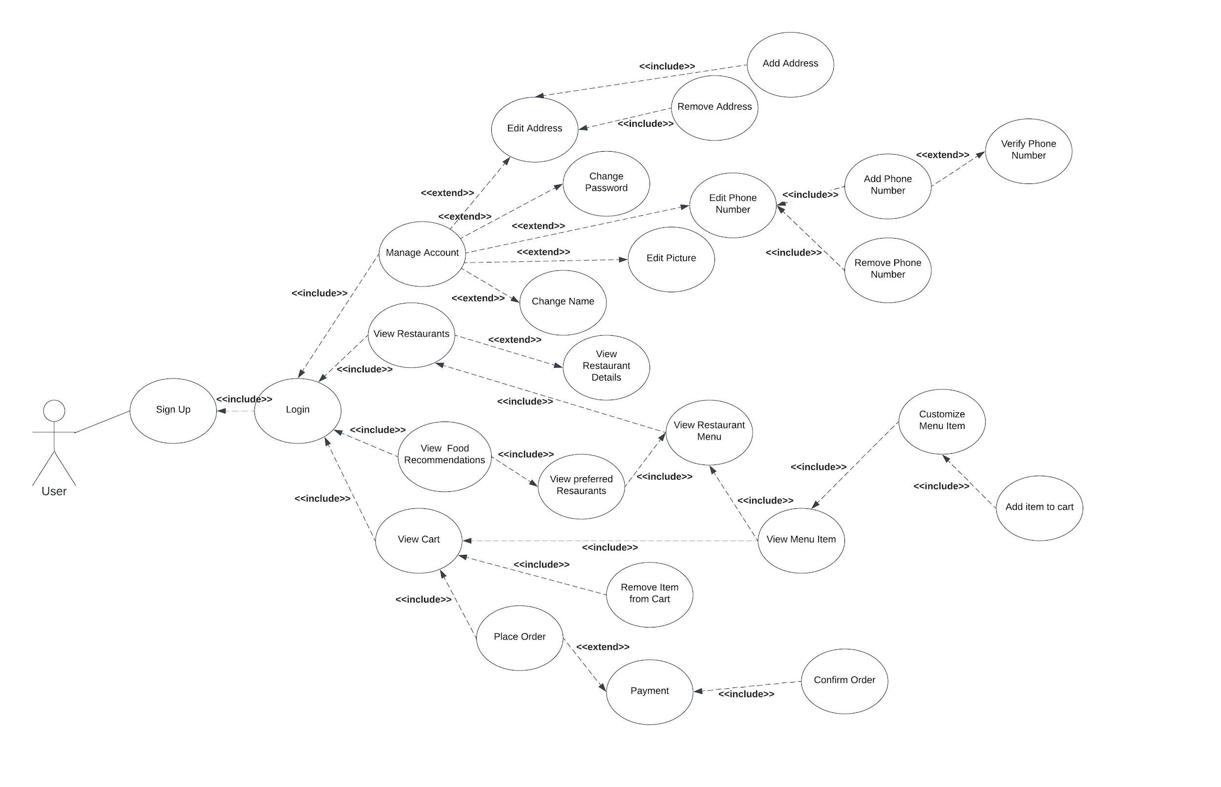

###### *Figure 1.1 Usecase Diagram - User*

Usecase diagram detail

**Use Case: Sign Up (UC_01)**

|  |  |
| --- | --- |
| Use Case ID | UC_01 |
| Use Case Name | Sign Up |
| Description | The Sign Up use case allows users to create an account by providing necessary details such as name, email, and password. |
| Primary Actor | User |
| Secondary Actor | - |
| Pre-Condition | None |
| Post-Condition | Access to user account |
| Basic Flow | 1. Click on "Sign Up"  2. Enter required details  3. Click "Register" or "Login" |
| Alternate Flow | Ask an admin to create or add the user |

##### *Table 2.1: Use Case – Customer Sign Up*

**Use Case: Login (UC_02)**

|  |  |
| --- | --- |
| Use Case ID | UC_02 |
| Use Case Name | Login |
| Description | The Login use case enables users to access their account by entering their registered email and password. |
| Primary Actor | User |
| Secondary Actor | - |
| Pre-Condition | Registered account |
| Post-Condition | Access to user account |
| Basic Flow | 1. Enter email and password  2. Click "Login" |
| Alternate Flow | None |

##### *Table 2.2: Use Case – Customer Login*

**Use Case: Manage Account (UC_03)**

|  |  |
| --- | --- |
| Use Case ID | UC_03 |
| Use Case Name | Manage Account |
| Description | The Manage Account use case allows users to modify various account details such as address, password, phone number, picture, and name. |
| Primary Actor | User |
| Secondary Actor | - |
| Pre-Condition | Logged in |
| Post-Condition | Updated account details |
| Basic Flow | 1. Click "Manage Account"  2. Choose from options: Edit Address, Change Password, Edit Phone Number, Edit Picture, Change Name  3. Follow relevant sub-flows |
| Alternate Flow | Ask an admin to make changes |

##### *Table 2.3: Use Case – Customer Manage Account*

**Use Case: Edit Address (UC_03.1)**

|  |  |
| --- | --- |
| Use Case ID | UC_03.1 |
| Use Case Name | Edit Address |
| Description | The Edit Address sub-use case allows users to add or remove addresses from their account. |
| Primary Actor | User |
| Secondary Actor | - |
| Pre-Condition | Logged in |
| Post-Condition | Updated address list |
| Basic Flow | 1. Click "Edit Address"  2. Choose from options: Add Address, Remove Address  3. Follow relevant sub-flows |
| Alternate Flow | None |

##### *Table 2.4: Use Case – Customer Edit Address*

**Use Case: Add Address (UC_03.1.1)**

|  |  |
| --- | --- |
| Use Case ID | UC_03.1.1 |
| Use Case Name | Add Address |
| Description | The Add Address sub-use case allows users to add a new address to their account. |
| Primary Actor | User |
| Secondary Actor | - |
| Pre-Condition | Logged in |
| Post-Condition | Updated address list |
| Basic Flow | 1. Click "Add Address"  2. Enter new address details  3. Confirm and save |
| Alternate Flow | None |

##### *Table 2.5: Use Case – Customer Add Address*

**Use Case: Remove Address (UC_03.1.2)**

|  |  |
| --- | --- |
| Use Case ID | UC_03.1.2 |
| Use Case Name | Remove Address |
| Description | The Remove Address sub-use case allows users to delete an existing address from their account. |
| Primary Actor | User |
| Secondary Actor | - |
| Pre-Condition | Logged in |
| Post-Condition | Updated address list |
| Basic Flow | 1. Click "Remove Address"  2. Select address to remove  3. Confirm deletion |
| Alternate Flow | None |

##### *Table 2.6: Use Case – Customer Remove Address*

**Use Case: Change Password (UC_03.2)**

|  |  |
| --- | --- |
| Use Case ID | UC_03.2 |
| Use Case Name | Change Password |
| Description | The Change Password sub-use case allows users to update their account password. |
| Primary Actor | User |
| Secondary Actor | - |
| Pre-Condition | Logged in |
| Post-Condition | Updated password |
| Basic Flow | 1. Click "Change Password"  2. Enter current and new password  3. Confirm and save |
| Alternate Flow | None |

##### *Table 2.7: Use Case – Customer Change Password*

**Use Case: Edit Phone Number (UC_03.3)**

|  |  |
| --- | --- |
| Use Case ID | UC_03.3 |
| Use Case Name | Edit Phone Number |
| Description | The Edit Phone Number sub-use case allows users to add or remove phone numbers from their account. |
| Primary Actor | User |
| Secondary Actor | - |
| Pre-Condition | Logged in |
| Post-Condition | Updated phone number list |
| Basic Flow | 1. Click "Edit Phone Number"  2. Choose from options: Add Phone Number, Remove Phone Number  3. Follow relevant sub-flows |
| Alternate Flow | None |

##### *Table 2.8: Use Case – Customer Edit Phone Number*

**Use Case: Add Phone Number (UC_03.3.1)**

|  |  |
| --- | --- |
| Use Case ID | UC_03.3.1 |
| Use Case Name | Add Phone Number |
| Description | The Add Phone Number sub-use case allows users to add a new phone number to their account and verify it. |
| Primary Actor | User |
| Secondary Actor | - |
| Pre-Condition | Logged in |
| Post-Condition | Updated phone number list |
| Basic Flow | 1. Click "Add Phone Number"  2. Enter new phone number  3. Verify phone number  4. Confirm and save |
| Alternate Flow | None |

##### *Table 2.9: Use Case – Customer Add Phone Number*

**Use Case: Remove Phone Number (UC_03.3.2)**

|  |  |
| --- | --- |
| Use Case ID | UC_03.3.2 |
| Use Case Name | Remove Phone Number |
| Description | The Remove Phone Number sub-use case allows users to delete an existing phone number from their account. |
| Primary Actor | User |
| Secondary Actor | - |
| Pre-Condition | Logged in |
| Post-Condition | Updated phone number list |
| Basic Flow | 1. Click "Remove Phone Number"  2. Select phone number to remove  3. Confirm deletion |
| Alternate Flow | None |

##### *Table 2.10: Use Case – Customer Remove Phone Number*

**Use Case: Edit Picture (UC_03.4)**

|  |  |
| --- | --- |
| Use Case ID | UC_03.4 |
| Use Case Name | Edit Picture |
| Description | The Edit Picture sub-use case allows users to update their profile picture. |
| Primary Actor | User |
| Secondary Actor | - |
| Pre-Condition | Logged in |
| Post-Condition | Updated profile picture |
| Basic Flow | 1. Click "Edit Picture"  2. Upload a new profile picture  3. Confirm and save |
| Alternate Flow | None |

##### *Table 2.11: Use Case – Customer Edit Picture*

**Use Case: Change Name (UC_03.5)**

|  |  |
| --- | --- |
| Use Case ID | UC_03.5 |
| Use Case Name | Change Name |
| Description | The Change Name sub-use case allows users to update their displayed name. |
| Primary Actor | User |
| Secondary Actor | - |
| Pre-Condition | Logged in |
| Post-Condition | Updated displayed name |
| Basic Flow | 1. Click "Change Name"  2. Enter new name  3. Confirm and save |
| Alternate Flow | None |

##### *Table 2.12: Use Case – Customer Change Name*

**Use Case: View Restaurants (UC_04)**

|  |  |
| --- | --- |
| Use Case ID | UC_04 |
| Use Case Name | View Restaurants |
| Description | The View Restaurants use case provides users with a list of available restaurants based on location and ratings. |
| Primary Actor | User |
| Secondary Actor | - |
| Pre-Condition | Logged in |
| Post-Condition | List of available restaurants |
| Basic Flow | 1. Click "View Restaurants"  2. View list of restaurants based on location and ratings |
| Alternate Flow | None |

##### *Table 2.13: Use Case – Customer View Restaurants*

**Use Case: View Restaurant Details (UC_04.1)**

|  |  |
| --- | --- |
| Use Case ID | UC_04.1 |
| Use Case Name | View Restaurant Details |
| Description | The View Restaurant Details sub-use case displays comprehensive information about a specific restaurant, including its name, menu, availability, rating, and reviews. |
| Primary Actor | User |
| Secondary Actor | - |
| Pre-Condition | Logged in |
| Post-Condition | Detailed restaurant information |
| Basic Flow | 1. Click "View Restaurant Details"  2. Enter restaurant identifier  3. View detailed information |
| Alternate Flow | None |

##### *Table 2.14: Use Case – Customer View Restaurant Details*

**Use Case: View Restaurant Menu (UC_04.2)**

|  |  |
| --- | --- |
| Use Case ID | UC_04.2 |
| Use Case Name | View Restaurant Menu |
| Description | The View Restaurant Menu sub-use case shows the menu of a specific restaurant. |
| Primary Actor | User |
| Secondary Actor | - |
| Pre-Condition | Logged in |
| Post-Condition | Restaurant menu |
| Basic Flow | 1. Click "View Restaurant Menu"  2. Enter restaurant identifier  3. View menu |
| Alternate Flow | None |

##### *Table 2.15: Use Case – Customer View Restaurant Menu*

**Use Case: View Food Recommendations (UC_05)**

|  |  |
| --- | --- |
| Use Case ID | UC_05 |
| Use Case Name | View Food Recommendations |
| Description | The View Food Recommendations use case allows users to discover personalized food recommendations based on their preferences. |
| Primary Actor | User |
| Secondary Actor | - |
| Pre-Condition | Logged in |
| Post-Condition | List of recommended restaurants |
| Basic Flow | 1. Click "View Food Recommendations"  2. View personalized recommendations |
| Alternate Flow | None |

##### *Table 2.16: Use Case – Customer View Food Recommendations*

**Use Case: View Preferred Restaurants (UC_05.1)**

|  |  |
| --- | --- |
| Use Case ID | UC_05.1 |
| Use Case Name | View Preferred Restaurants |
| Description | The View Preferred Restaurants sub-use case shows users a list of their favorite restaurants. |
| Primary Actor | User |
| Secondary Actor | - |
| Pre-Condition | Logged in |
| Post-Condition | List of favorite restaurants |
| Basic Flow | 1. Click "View Preferred Restaurants"  2. View list of favorite restaurants |
| Alternate Flow | None |

##### *Table 2.17: Use Case – Customer View Preferred Restaurants*

**Use Case: View Restaurant Menu (Preferred) (UC_05.1.1)**

|  |  |
| --- | --- |
| Use Case ID | UC_05.1.1 |
| Use Case Name | View Restaurant Menu (Preferred) |
| Description | The View Restaurant Menu sub-use case displays the menu of a specific restaurant within the preferred list. |
| Primary Actor | User |
| Secondary Actor | - |
| Pre-Condition | Logged in |
| Post-Condition | Restaurant menu |
| Basic Flow | 1. Click "View Restaurant Menu"  2. Enter restaurant identifier |
| Alternate Flow | None |

##### *Table 2.18: Use Case – Customer View Preferred Restaurant Menu*

**Use Case: View Cart (UC_06)**

|  |  |
| --- | --- |
| Use Case ID | UC_06 |
| Use Case Name | View Cart |
| Description | The View Cart use case enables users to review the selected items in their cart along with the total amount. |
| Primary Actor | User |
| Secondary Actor | - |
| Pre-Condition | Logged in |
| Post-Condition | Overview of selected items and total amount |
| Basic Flow | 1. Click "View Cart"  2. View list of selected items with prices  3. Display total amount |
| Alternate Flow | None |

##### *Table 2.19: Use Case – Customer View Cart*

**Use Case: Remove Item from Cart (UC_06.1)**

|  |  |
| --- | --- |
| Use Case ID | UC_06.1 |
| Use Case Name | Remove Item from Cart |
| Description | The Remove Item from Cart sub-use case allows users to delete a selected item from their cart. |
| Primary Actor | User |
| Secondary Actor | - |
| Pre-Condition | Logged in |
| Post-Condition | Updated cart with removed item |
| Basic Flow | 1. Click "Remove Item from Cart"  2. Select item to remove  3. Confirm removal |
| Alternate Flow | None |

##### *Table 2.20: Use Case – Customer Remove Item from Cart*

**Use Case: Place Order (UC_06.2)**

|  |  |
| --- | --- |
| Use Case ID | UC_06.2 |
| Use Case Name | Place Order |
| Description | The Place Order use case allows users to confirm and place an order for the selected items in their cart. |
| Primary Actor | User |
| Secondary Actor | - |
| Pre-Condition | Logged in |
| Post-Condition | Order placed |
| Basic Flow | 1. Click "Place Order"  2. Proceed to payment  3. Confirm order |
| Alternate Flow | Payment confirmation |

##### *Table 2.21: Use Case – Customer Place Order*

**Use Case: Payment (UC_06.2.1)**

|  |  |
| --- | --- |
| Use Case ID | UC_06.2.1 |
| Use Case Name | Payment |
| Description | The Payment sub-use case involves the user selecting a payment method and confirming the order. |
| Primary Actor | User |
| Secondary Actor | - |
| Pre-Condition | Logged in |
| Post-Condition | Order confirmed |
| Basic Flow | 1. Select payment method  2. Confirm order |
| Alternate Flow | None |

##### *Table 2.22: Use Case – Customer Payment*

**Use Case: Confirm Order (UC_06.2.1.1)**

|  |  |
| --- | --- |
| Use Case ID | UC_06.2.1.1 |
| Use Case Name | Confirm Order |
| Description | The Confirm Order sub-use case finalizes the order placement, and the system acknowledges the successful transaction. |
| Primary Actor | User |
| Secondary Actor | - |
| Pre-Condition | Logged in |
| Post-Condition | Order confirmed |
| Basic Flow | 1. Confirm order  2. Receive confirmation message |
| Alternate Flow | None |

##### *Table 2.23: Use Case – Customer Confirm Order*

**Use Case: View Favorites (UC_07)**

|  |  |
| --- | --- |
| Use Case ID | UC_07 |
| Use Case Name | View Favorites |
| Description | The View Favorites use case allows users to access and view their favorite restaurants and items for a personalized ordering experience. |
| Primary Actor | User |
| Secondary Actor | - |
| Pre-Condition | Logged in |
| Post-Condition | List of favorite restaurants and items |
| Basic Flow | 1. Click "View Favorites"  2. View list of favorite restaurants and items |
| Alternate Flow | None |

##### *Table 2.24: Use Case – Customer View Favorites*

**Use Case: Order History (UC_08)**

|  |  |
| --- | --- |
| Use Case ID | UC_08 |
| Use Case Name | Order History |
| Description | The Order History use case allows users to access and view both their current and previous orders. |
| Primary Actor | User |
| Secondary Actor | - |
| Pre-Condition | Logged in |
| Post-Condition | List of current and previous orders |
| Basic Flow | 1. Click "Order History"  2. View list of orders |
| Alternate Flow | None |

##### *Table 2.25: Use Case – Customer Order History*

**Use Case: Payment Method - Cash on Delivery (COD) (UC_09)**

|  |  |
| --- | --- |
| Use Case ID | UC_09 |
| Use Case Name | Payment Method - Cash on Delivery (COD) |
| Description | The Payment Method - Cash on Delivery (COD) use case allows users to make payments for their orders using the Cash on Delivery method. |
| Primary Actor | User |
| Secondary Actor | - |
| Pre-Condition | Logged in |
| Post-Condition | Order confirmed with COD payment |
| Basic Flow | 1. Select "Cash on Delivery" as payment method  2. Confirm order |
| Alternate Flow | None |

##### *Table 2.26: Use Case – Customer Payment Method*

###### *Figure 1.2 Usecase Diagram - Admin / Restaurant*

Usecase diagram detail

**Use Case 10: Login (UC_10)**

|  |  |
| --- | --- |
| **Use Case ID** | **UC_10** |
| **Use Case Name** | Login |
| **Description** | Allows admins/restaurants to log into the system. |
| **Primary Actor** | Admin/Restaurant |
| **Pre-Condition** | - |
| **Post-Condition** | Successful login |
| **Basic Flow** | 1. Navigate to login page |
|  | 2. Enter credentials |
|  | 3. Click on "Login" button |
|  | 4. Redirect to dashboard |
| **Alternate Flow** | - |

##### *Table 2.27: Use Case – Restaurant Login*

**Use Case 11: Manage Account (UC_11)**

|  |  |
| --- | --- |
| **Use Case ID** | **UC_11** |
| **Use Case Name** | Manage Account |
| **Description** | Allows admins/restaurants to manage their account settings. |
| **Primary Actor** | Admin/Restaurant |
| **Pre-Condition** | Logged into the account |
| **Post-Condition** | Changes to account settings are saved. |
| **Basic Flow** | 1. Navigate to account settings |
|  | 2. Edit account details |
|  | 3. Save changes |
| **Alternate Flow** | Cancel changes |

##### *Table 2.28: Use Case – Restaurant Manage Account*

**Use Case 12: Dashboard (UC_12)**

|  |  |
| --- | --- |
| **Use Case ID** | **UC_12** |
| **Use Case Name** | Dashboard |
| **Description** | Provides an overview of restaurant activities and options. |
| **Primary Actor** | Admin/Restaurant |
| **Pre-Condition** | Logged into the account |
| **Post-Condition** | - |
| **Basic Flow** | 1. Navigate to the dashboard |
|  | 2. View summary data |
| **Alternate Flow** | - |

##### *Table 2.29: Use Case – Restaurant Dashboard*

**Use Case 13: Edit Restaurant Details (UC_13)**

|  |  |
| --- | --- |
| **Use Case ID** | **UC_13** |
| **Use Case Name** | Edit Restaurant Details |
| **Description** | Allows admins/restaurants to edit details such as location, picture, and timings. |
| **Primary Actor** | Admin/Restaurant |
| **Pre-Condition** | Logged into the account |
| **Post-Condition** | Changes to restaurant details are saved. |
| **Basic Flow** | 1. Navigate to restaurant details |
|  | 2. Edit details |
|  | 3. Save changes |
| **Alternate Flow** | Cancel changes |

##### *Table 2.30: Use Case – Restaurant Edit Restaurant Details*

**Use Case 14: Edit Restaurant Menu (UC_14)**

|  |  |
| --- | --- |
| **Use Case ID** | **UC_14** |
| **Use Case Name** | Edit Restaurant Menu |
| **Description** | Allows admins/restaurants to add, edit, or delete items from the menu. |
| **Primary Actor** | Admin/Restaurant |
| **Pre-Condition** | Logged into the account |
| **Post-Condition** | Changes to the menu are saved. |
| **Basic Flow** | 1. Navigate to restaurant menu |
|  | 2. Add, edit, or delete items |
|  | 3. Save changes |
| **Alternate Flow** | Cancel changes |

##### *Table 2.31: Use Case – Restaurant Edit Restaurant Menu*

**Use Case 15: Sales (UC_15)**

|  |  |
| --- | --- |
| **Use Case ID** | **UC_15** |
| **Use Case Name** | Sales |
| **Description** | Provides information about daily, weekly, monthly, and yearly sales. |
| **Primary Actor** | Admin/Restaurant |
| **Pre-Condition** | Logged into the account |
| **Post-Condition** | - |
| **Basic Flow** | 1. Navigate to sales data |
|  | 2. View sales information |
| **Alternate Flow** | - |

##### *Table 2.32: Use Case – Restaurant Sales*

**Use Case 16: Incoming Orders (UC_16)**

|  |  |
| --- | --- |
| **Use Case ID** | **UC_16** |
| **Use Case Name** | Incoming Orders |
| **Description** | Allows admins to view details of incoming orders and take action. |
| **Primary Actor** | Admin/Restaurant |
| **Pre-Condition** | Logged into the account |
| **Post-Condition** | - |
| **Basic Flow** | 1. Clicks on "Incoming Orders" |
|  | 2. Views order details |
| **Alternate Flow** | - |

##### *Table 2.33: Use Case – Restaurant Incoming Orders*

**Use Case 17: Pending Orders (UC_17)**

|  |  |
| --- | --- |
| **Use Case ID** | **UC_17** |
| **Use Case Name** | Pending Orders |
| **Description** | Allows admins to manage pending orders, including updating status and item availability. |
| **Primary Actor** | Admin/Restaurant |
| **Pre-Condition** | Logged into the account |
| **Post-Condition** | Changes to orders are saved. |
| **Basic Flow** | 1. Clicks on "Pending Orders" |
|  | 2. Views pending orders |
| **Alternate Flow** | - |

##### *Table 2.34: Use Case – Restaurant Pending Orders*

**Use Case 18: Customer Complaints/Feedback (UC_18)**

|  |  |
| --- | --- |
| **Use Case ID** | **UC_18** |
| **Use Case Name** | Customer Complaints/Feedback |
| **Description** | Allows admins to manage customer feedback and complaints. |
| **Primary Actor** | Admin/Restaurant |
| **Pre-Condition** | Logged into the account |
| **Post-Condition** | Changes to feedback are saved. |
| **Basic Flow** | 1. Clicks on "Customer Complaints/Feedback" |
|  | 2. Views feedback and complaints |
| **Alternate Flow** | - |

##### *Table 2.35: Use Case – Restaurant Customer Complaints/Feedback*

**Use Case 19: Completed Orders (UC_19)**

|  |  |
| --- | --- |
| **Use Case ID** | **UC_19** |
| **Use Case Name** | Completed Orders |
| **Description** | Allows admins to view details of completed orders. |
| **Primary Actor** | Admin/Restaurant |
| **Pre-Condition** | Logged into the account |
| **Post-Condition** | - |
| **Basic Flow** | 1. Clicks on "Completed Orders" |
|  | 2. Views details of completed orders |
| **Alternate Flow** | - |

##### *Table 2.36: Use Case – Restaurant Completed Orders*

**Use Case 20: Refunds (UC_20)**

|  |  |
| --- | --- |
| **Use Case ID** | **UC_20** |
| **Use Case Name** | Refunds |
| **Description** | Allows admins to manage refunds, issue refunds, and check refund status. |
| **Primary Actor** | Admin/Restaurant |
| **Pre-Condition** | Logged into the account |
| **Post-Condition** | Changes to refunds are saved. |
| **Basic Flow** | 1. Clicks on "Refunds" |
|  | 2. Manages refund requests |
| **Alternate Flow** | - |

##### *Table 2.37: Use Case – Restaurant Refunds*

# Chapter 4: Design

In this section, we provide the design analysis of our modules including the following designs

1. Architecture Diagram
2. ERD with data dictionary
3. Data Flow diagram
4. Class Diagram
5. Activity Diagram
6. Sequence Diagram
7. Collaboration Diagram
8. State Transition Diagram
9. Component Diagram
10. Deployment Diagram

#### Architecture Diagram

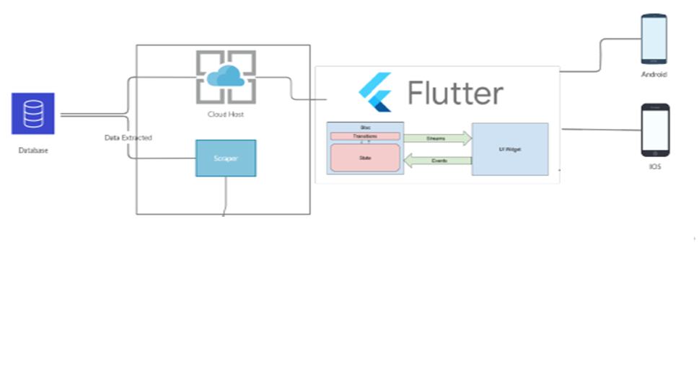

###### *Figure 2 Architecture Diagram*

#### ERD with data dictionary

EntityRelationshipDiagram with complete relations with dependencies of your project

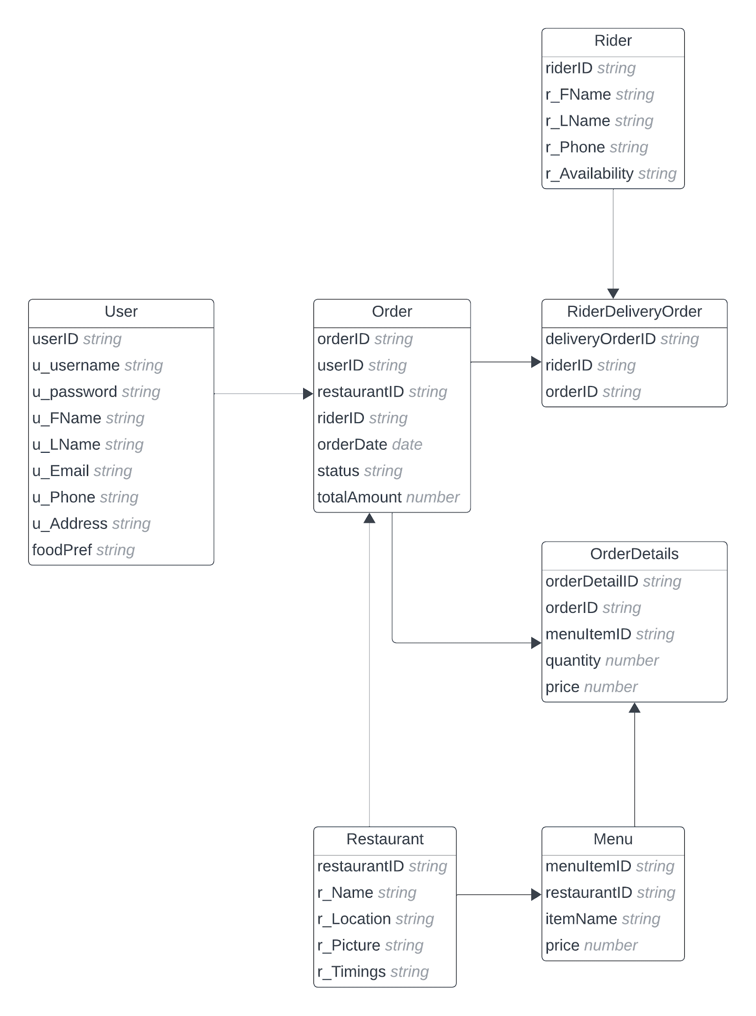

###### *Figure 3 ERD*

#### Data Flow diagram

Data flow diagram includes two levels

##### 4.3.1 The level 0

The flow of information inside the system is defined in this level

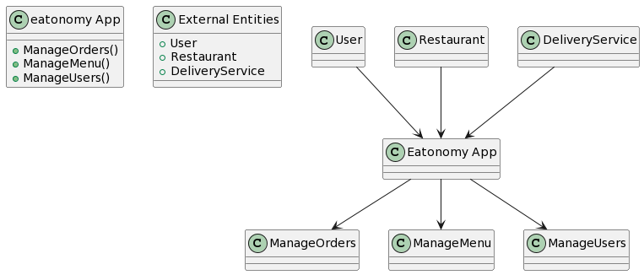

###### *Figure 4 Level 0 DFD*

##### 4.3.1 The level 1

The flow of information outside the system is defined in this level

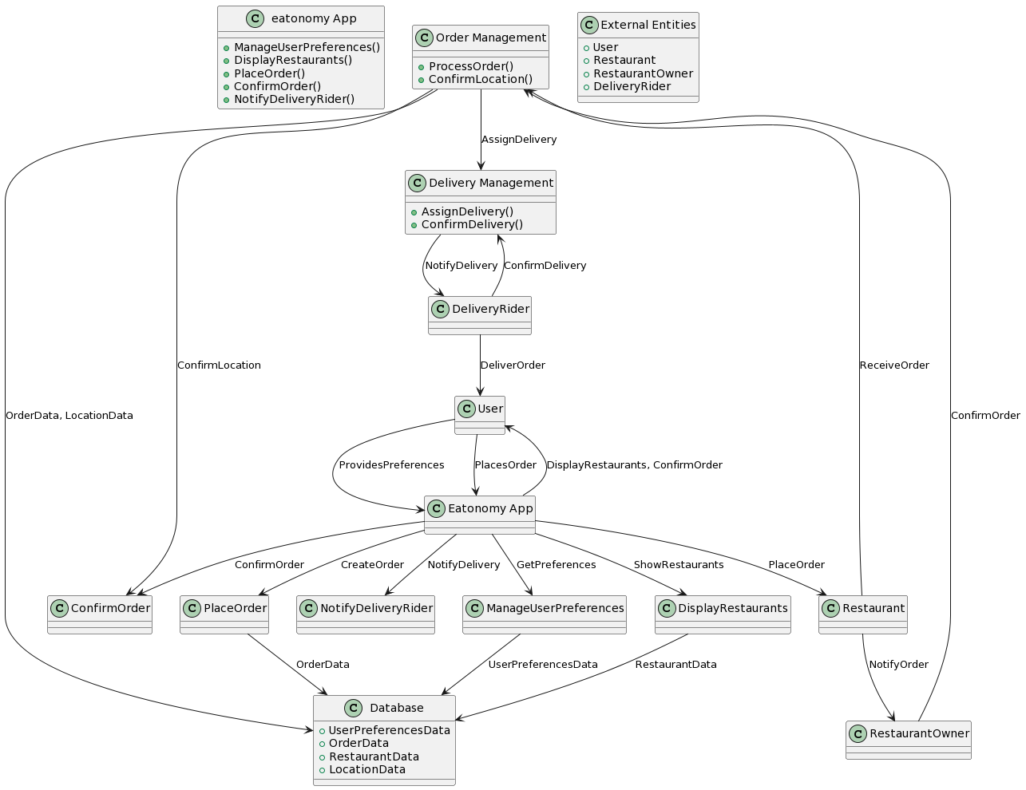

###### *Figure 5 Level 1 DFD*

#### Class Diagram

Describe the structure of a project by showing the systems classes, their attributes, operations (or methods), and the relationships among objects. 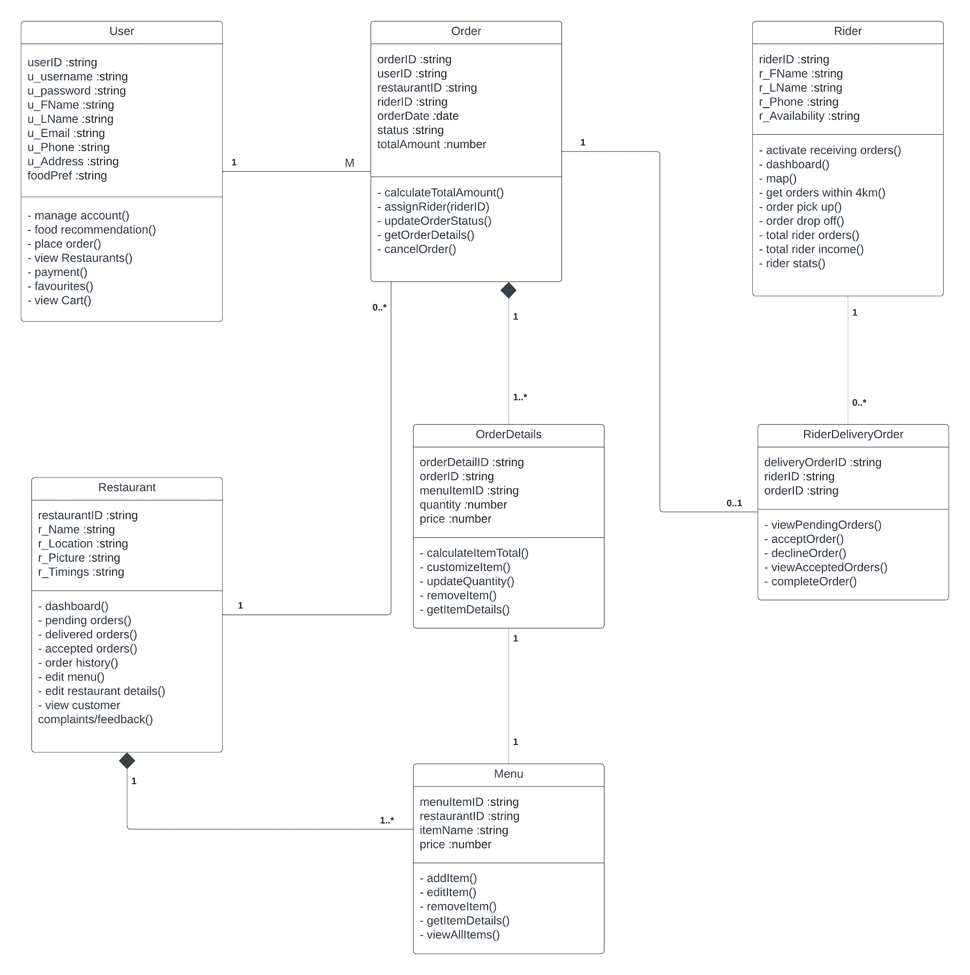

###### *Figure 6 Class Diagram*

#### Activity Diagram

This diagram includes all the activity diagrams of the functional requirements of our project along with the aggregated activity diagram

##### 4.5.1 Activity diagram for create account

###### *Figure 7.1 Activity diagram Create Account*

##### 4.5.2 Activity diagram for login account

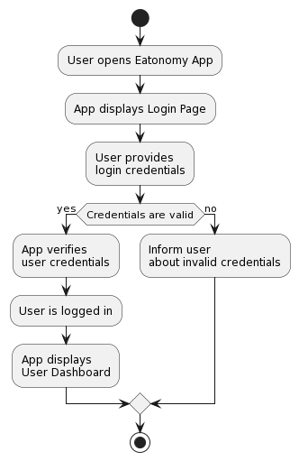

###### *Figure 7.2 Activity Diagram Login Account*

##### 4.5.3 Activity diagram for forgot password.

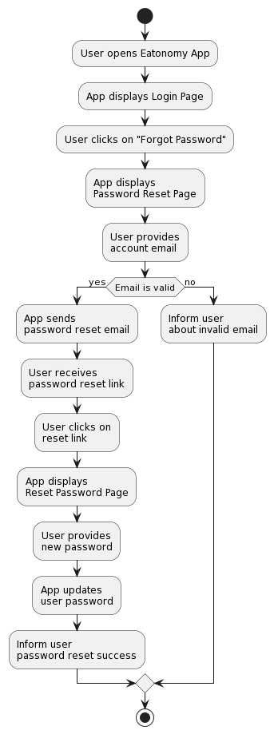

###### *Figure 7.3 Activity Diagram Forgot password*

##### 4.5.4 Activity diagram for Food Recommendation

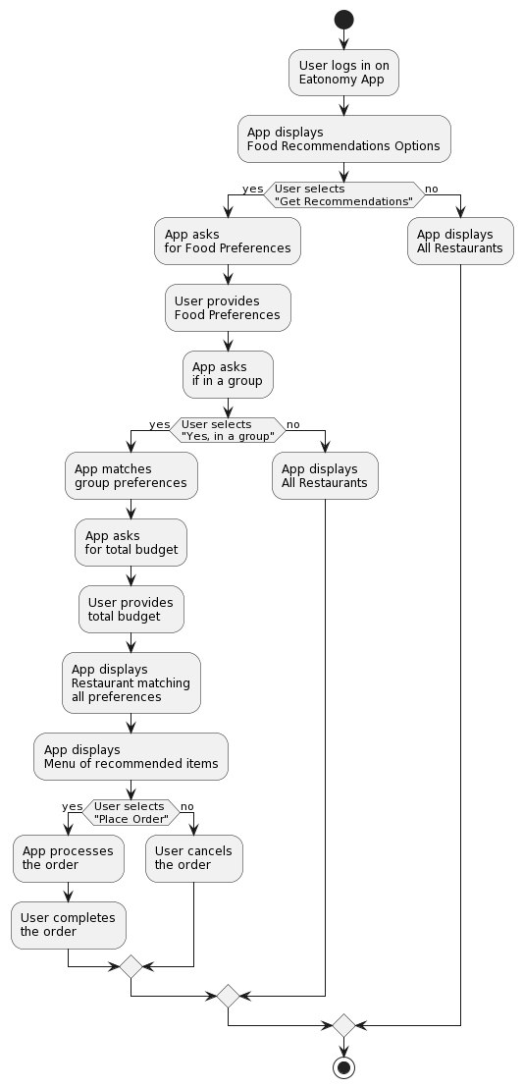

###### *Figure 7.4 Activity Diagram Food Recommendation*

##### 4.5.5 Activity diagram for account management

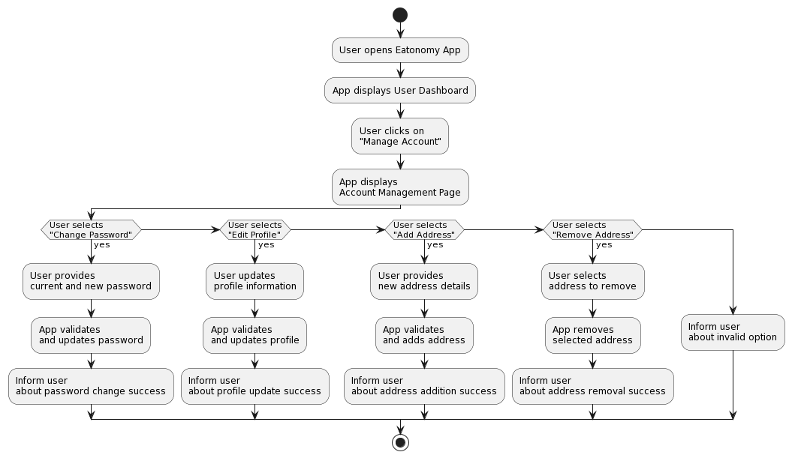

###### *Figure 7.5 Activity Diagram Account Management*

##### 4.5.6 Activity diagram for View Restaurant

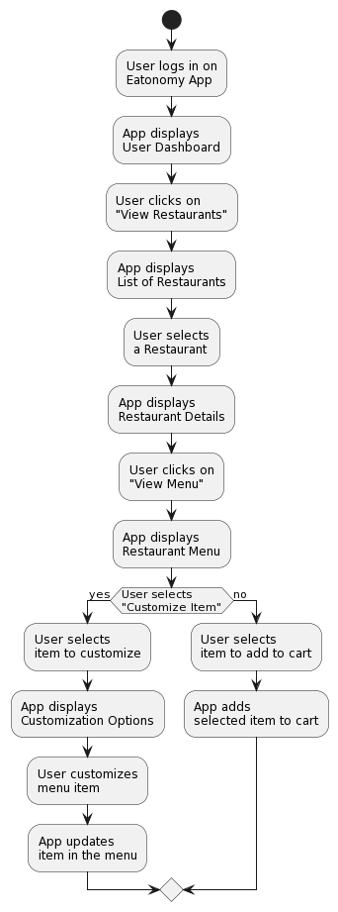

###### *Figure 7.6 Activity Diagram View Restaurant*

##### 4.5.7 Activity diagram for View Cart

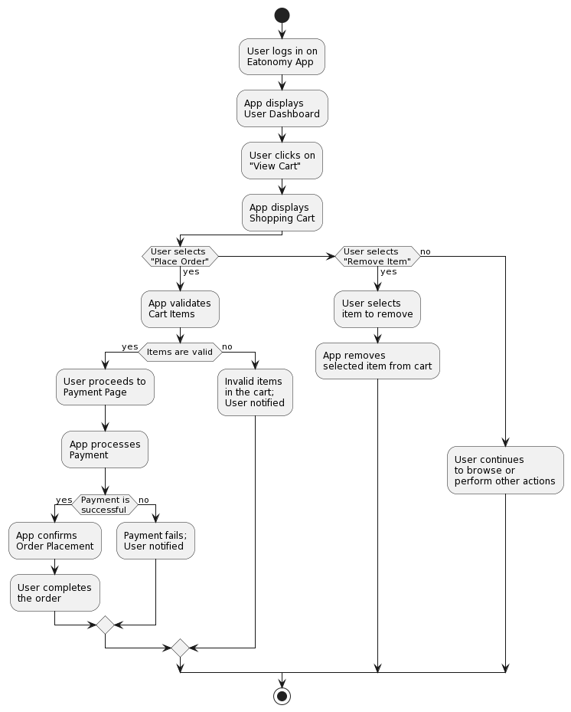

###### *Figure 7.7 Activity Diagram View Cart*

##### 4.5.8 Activity diagram for Restaurant Login

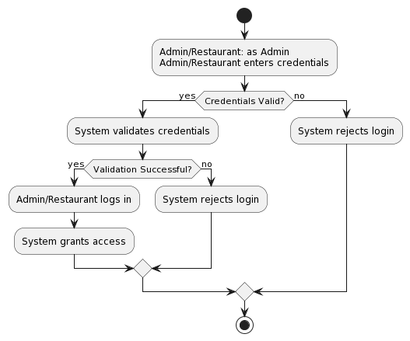

###### *Figure 7.8 Activity Diagram Restaurant Login*

##### 4.5.9 Activity diagram for Restaurant account management

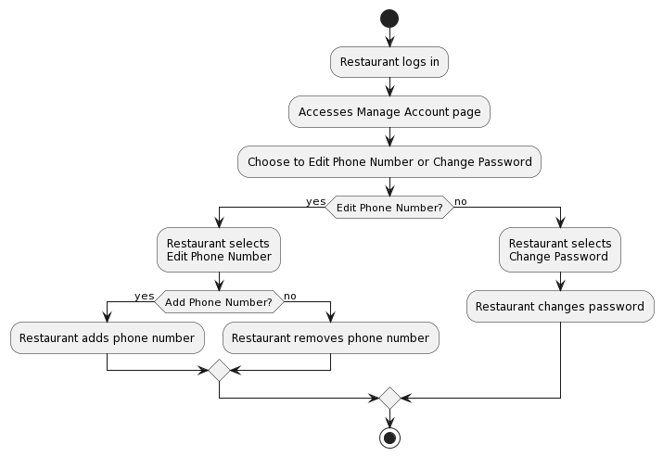

###### *Figure 7.9 Activity Diagram Restaurant Account Management*

##### 4.5.10 Activity diagram for Restaurant Edit Details

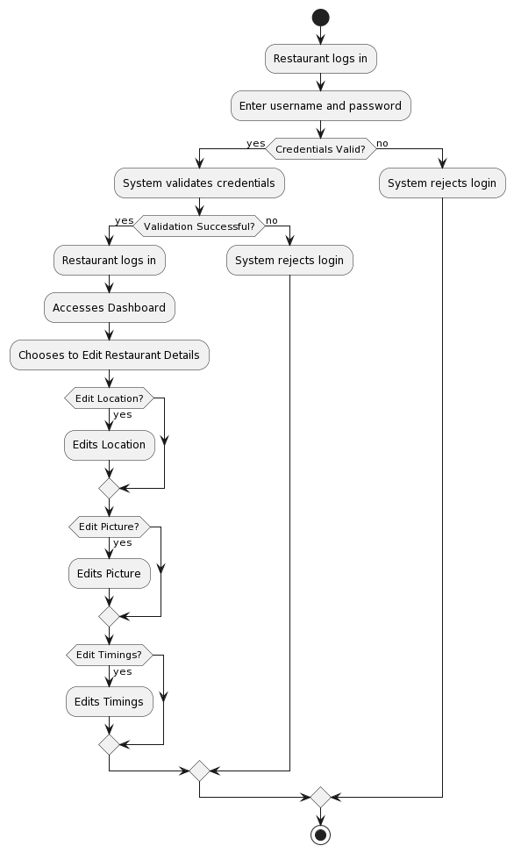

###### *Figure 7.10 Activity Diagram Restaurant Edit Details*

##### 4.5.11 Activity diagram for Restaurant Dashboard

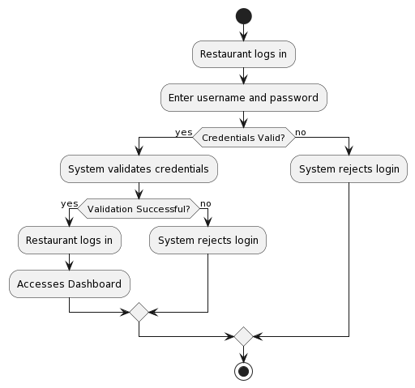

###### *Figure 7.11 Activity Diagram Restaurant Dashboard*

##### 4.5.12 Activity diagram for Edit Restaurant Menu

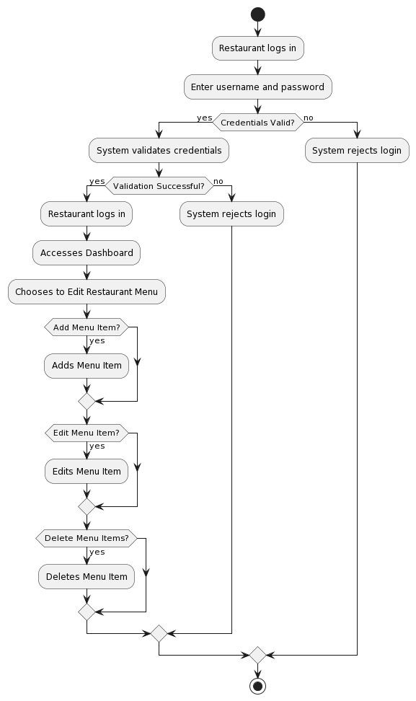

###### *Figure 7.12 Activity Diagram Edit Restaurant Menu*

##### 4.5.13 Activity diagram for Restaurant Sales

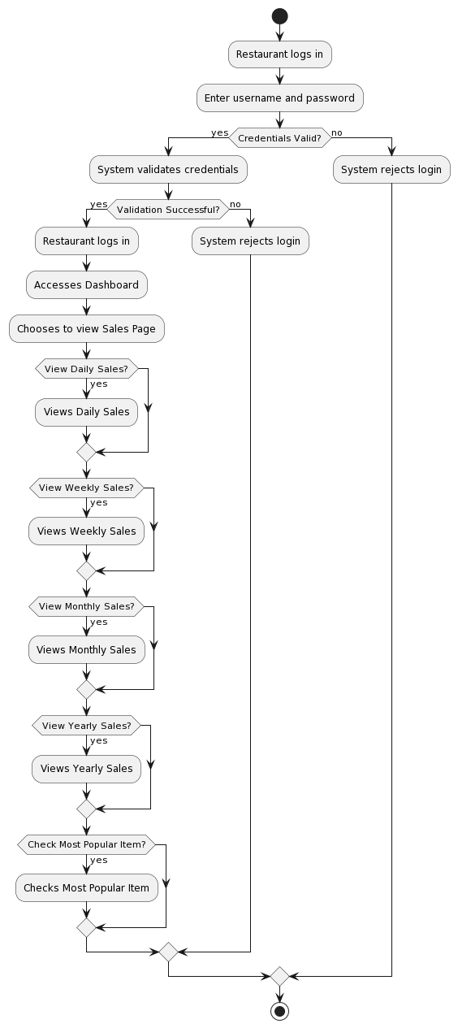

###### *Figure 7.13 Activity Diagram Restaurant Sales*

##### 4.5.14 Activity diagram for Restaurants incoming orders

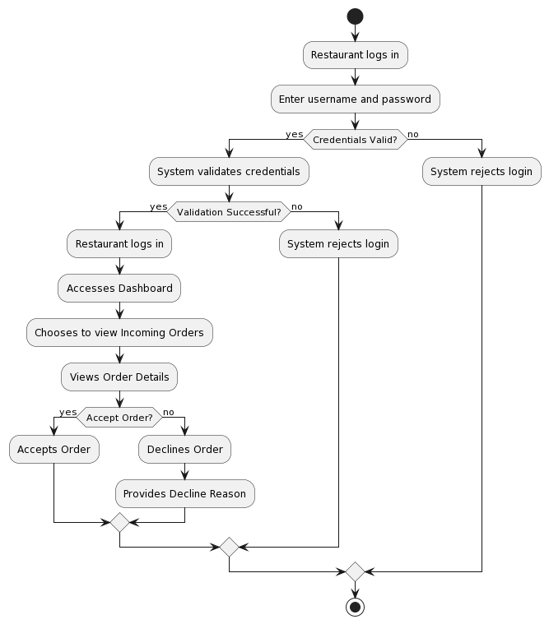

###### *Figure 7.14 Activity Diagram Restaurants incoming orders*

##### 4.5.15 Activity diagram for Pending Orders

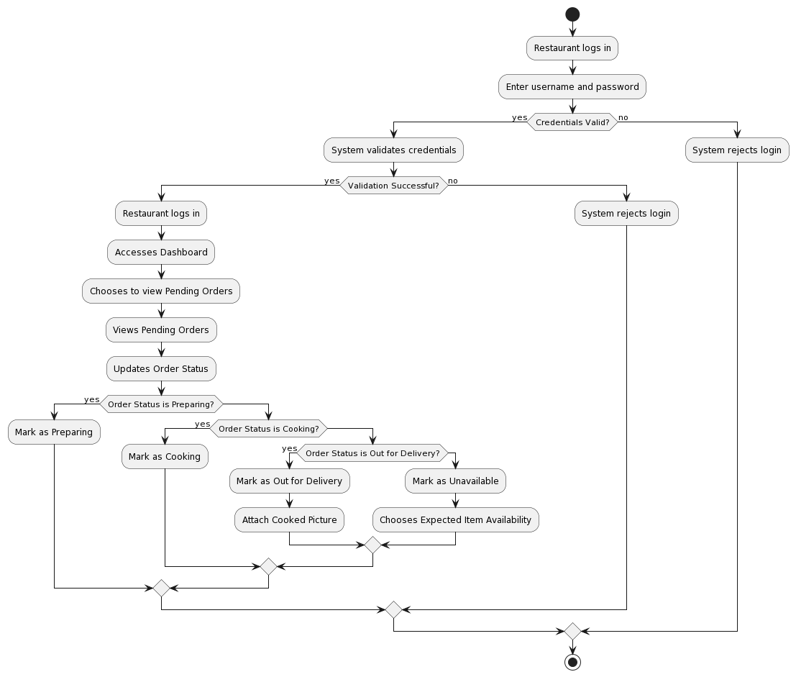

###### *Figure 7.15 Activity Diagram Pending Orders*

##### 4.5.16 Activity diagram for Customer Complaints/Feedback

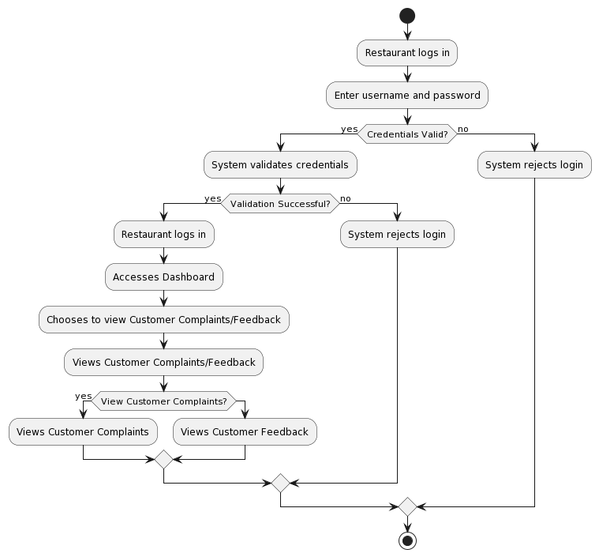

###### *Figure 7.16 Activity Diagram Customer Complaints/Feedback*

##### 4.5.17 Activity diagram for Completed Orders

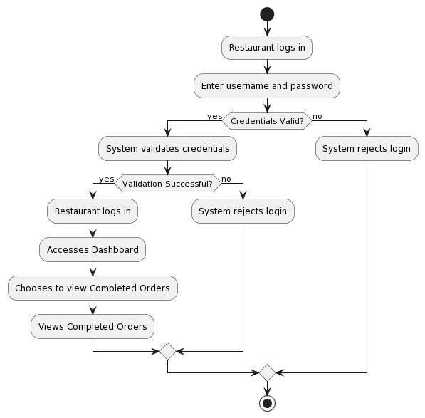

###### *Figure 7.17 Activity Diagram Completed Orders*

##### 4.5.18 Activity diagram for Refunds

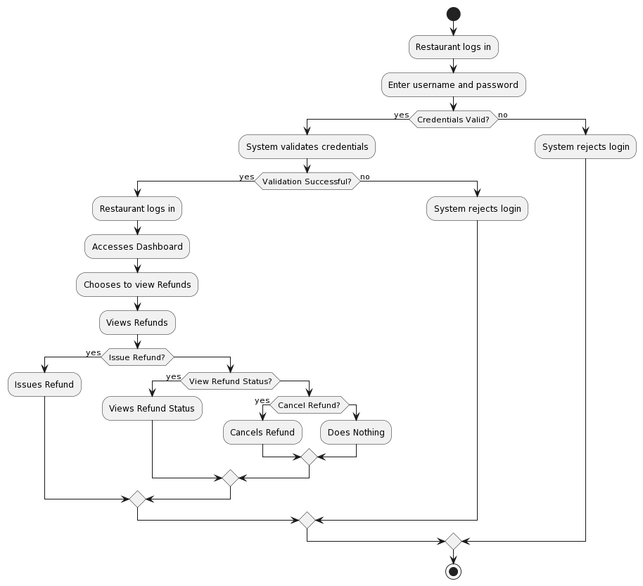

###### *Figure 7.18 Activity Diagram Refunds*

#### Sequence Diagram

This diagram includes all the Sequence diagrams of the functional requirements of our project along with the aggregated Sequence diagram

##### 4.6.1 Sequence diagram for create account

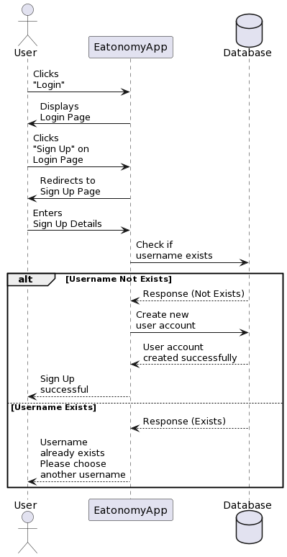

###### *Figure 8.1 Sequence Diagram Create Account*

##### 4.6.2 Sequence diagram for Login account

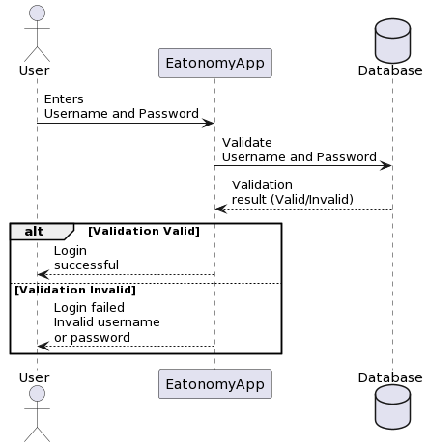

###### *Figure 8.2 Sequence Diagram Login Account*

##### 4.6.3 Sequence diagram for Forgot password

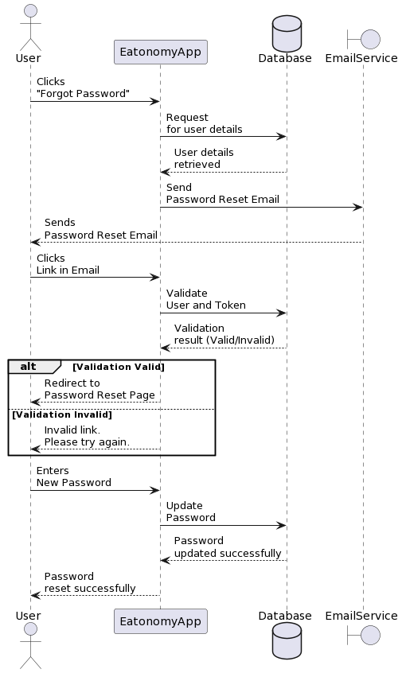

###### *Figure 8.3 Sequence Diagram Forgot Password*

##### 4.6.4 Sequence diagram for Food Recommender

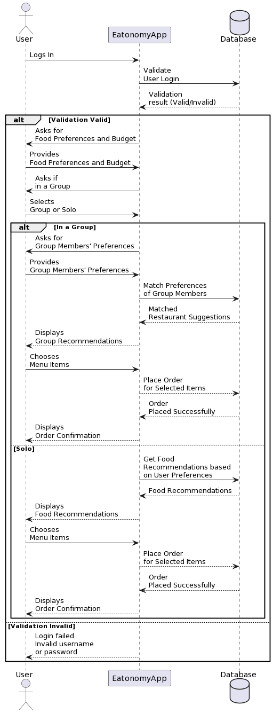

###### *Figure 8.4 Sequence Diagram Food Recommendation*

##### 4.6.5 Sequence diagram for manage account

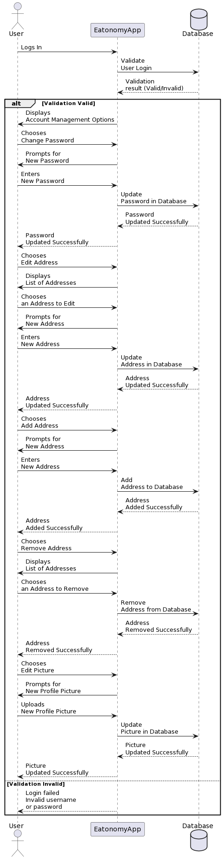

###### *Figure 8.5 Sequence Diagram manage account*

##### 4.6.6 Sequence diagram for View Restaurants

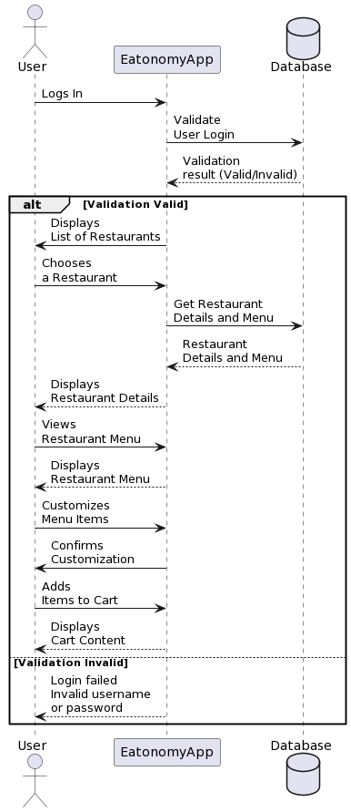

###### *Figure 8.6 Sequence Diagram View Restaurants*

##### 4.6.7 Sequence diagram for View Cart

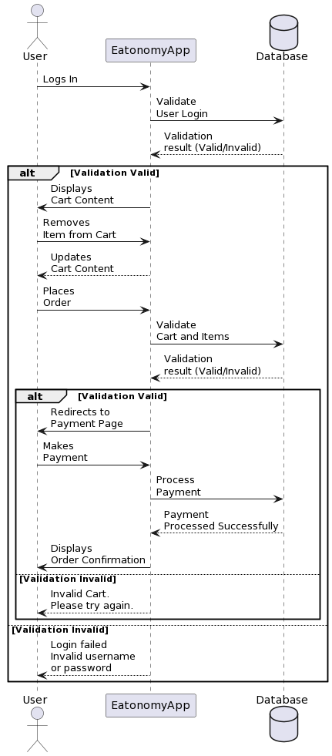

###### *Figure 8.7 Sequence Diagram View Cart*

##### 4.6.8 Sequence diagram for Restaurant Login

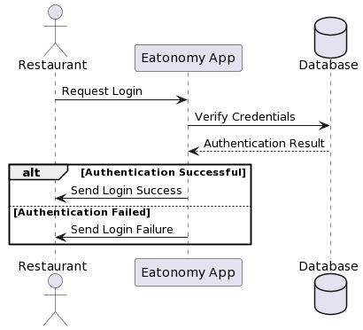

###### *Figure 8.8 Sequence Diagram Restaurant Login*

##### 4.6.9 Sequence diagram for Restaurant Dashboard

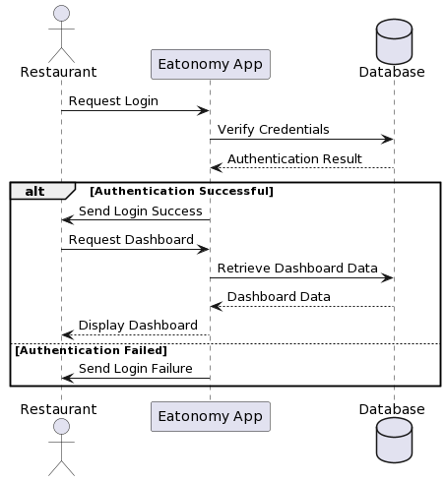

###### *Figure 8.9 Sequence Diagram Restaurant Dashboard*

##### 4.6.10 Sequence diagram for Restaurant Manage Account

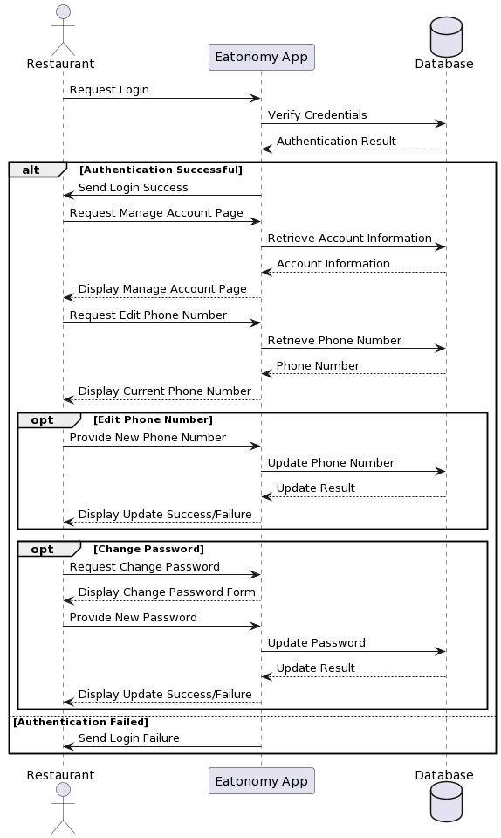

###### *Figure 8.10 Sequence Diagram Restaurant Manage Account*

##### 4.6.11 Sequence diagram for Edit Restaurant Details

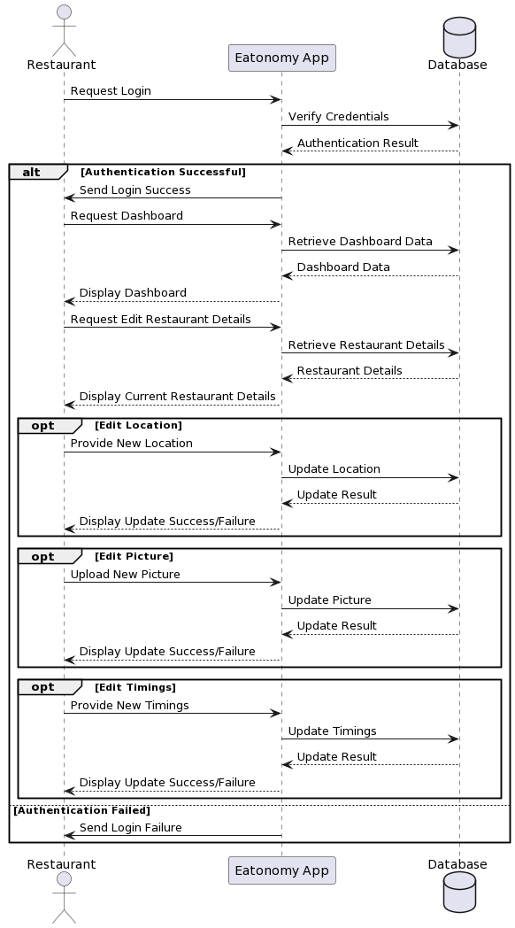

###### *Figure 8.11 Sequence Diagram Edit Restaurant Details*

##### 4.6.12 Sequence diagram for Edit Restaurant Menu

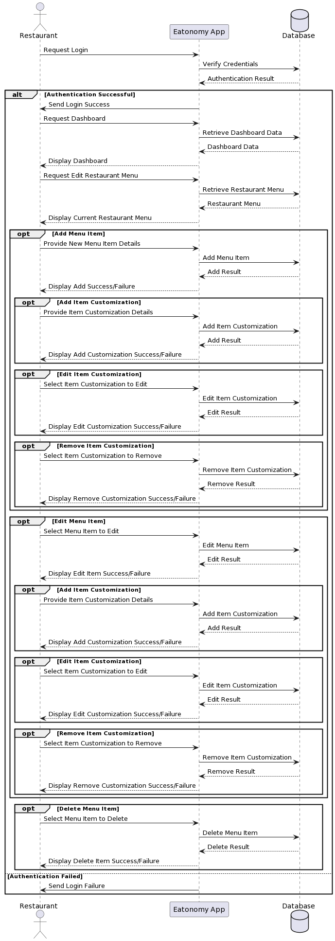

###### *Figure 8.12 Sequence Diagram Edit Restaurant Menu*

##### 4.6.13 Sequence diagram for Restaurant Sales

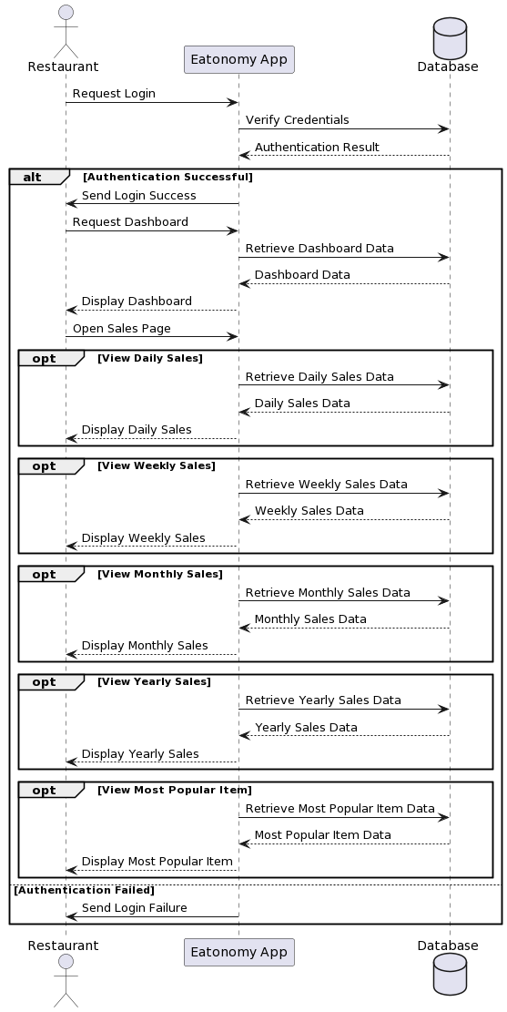

###### *Figure 8.13 Sequence Diagram Restaurant Sales*

##### 4.6.14 Sequence diagram for Restaurant Incoming Orders

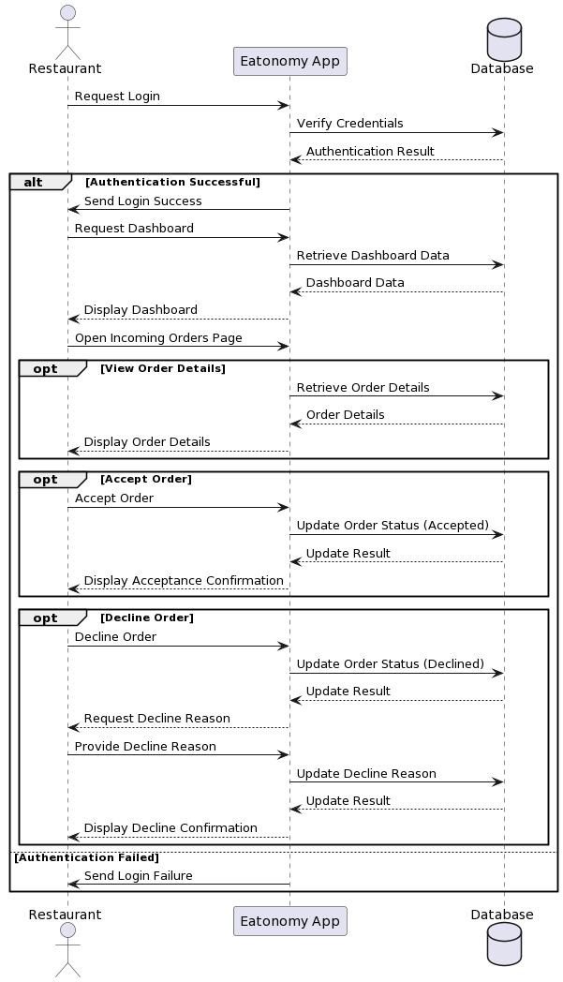

###### *Figure 8.14 Sequence Diagram Restaurant Incoming Orders*

##### 4.6.15 Sequence diagram for Restaurant Pending Orders

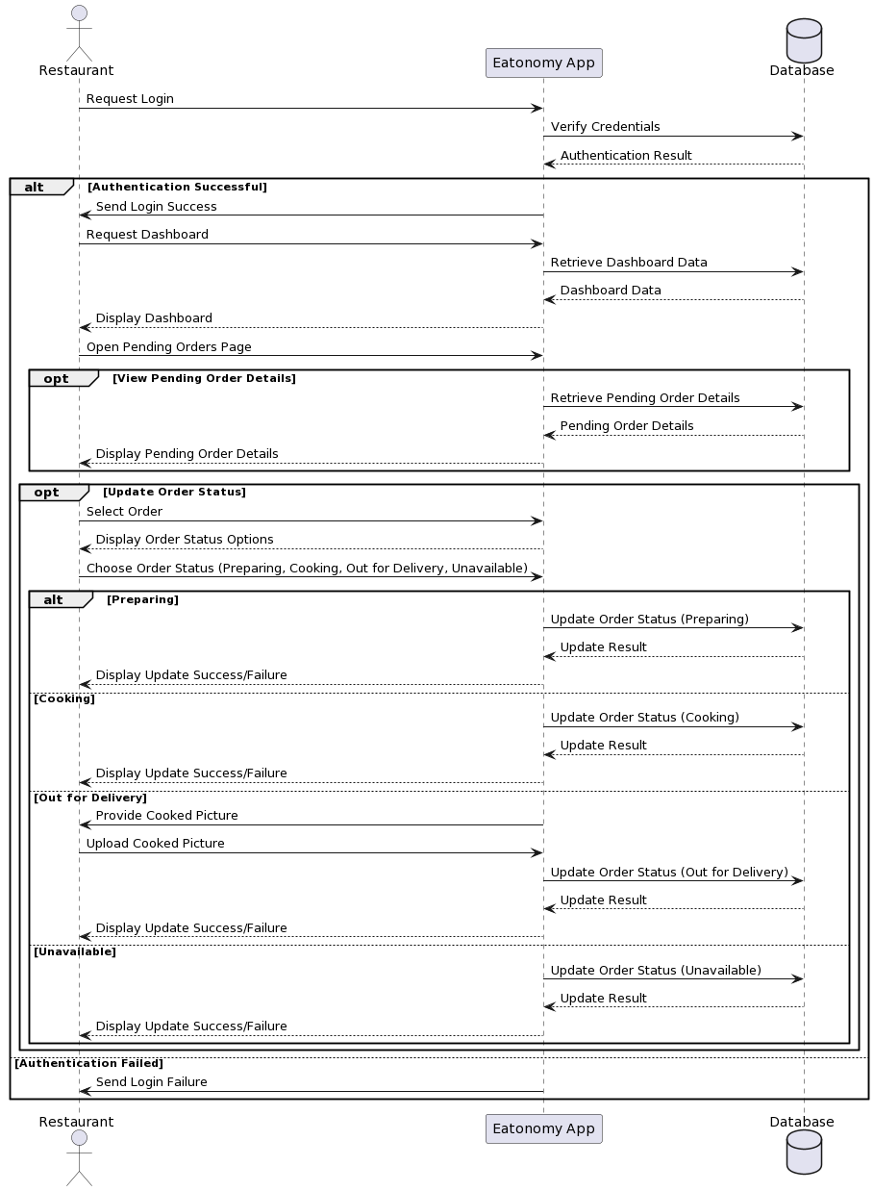

###### *Figure 8.15 Sequence Diagram Restaurant Pending Orders*

##### 4.6.16 Sequence diagram for Restaurant Customer Complaints/Feedback

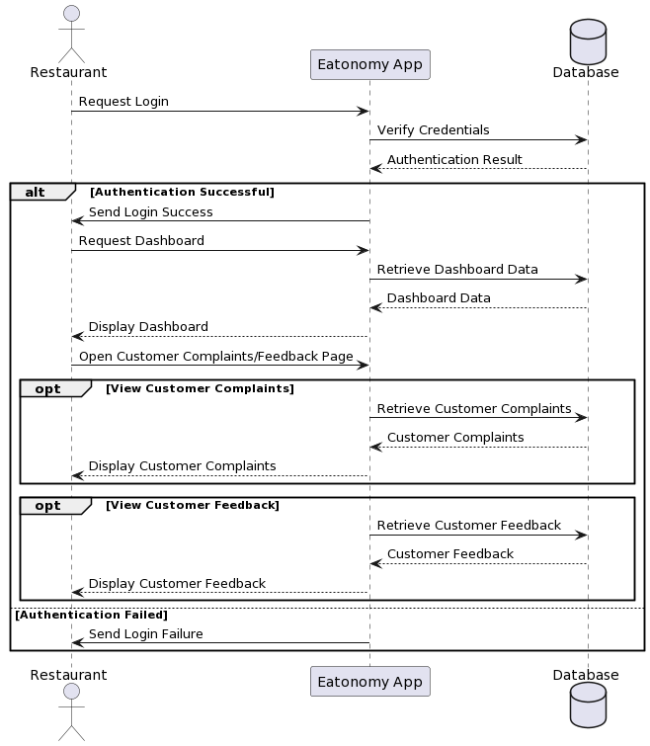

###### *Figure 8.16 Sequence Diagram Restaurant Customer Complaints/Feedback*

##### 4.6.17 Sequence diagram for Restaurant Completed Orders

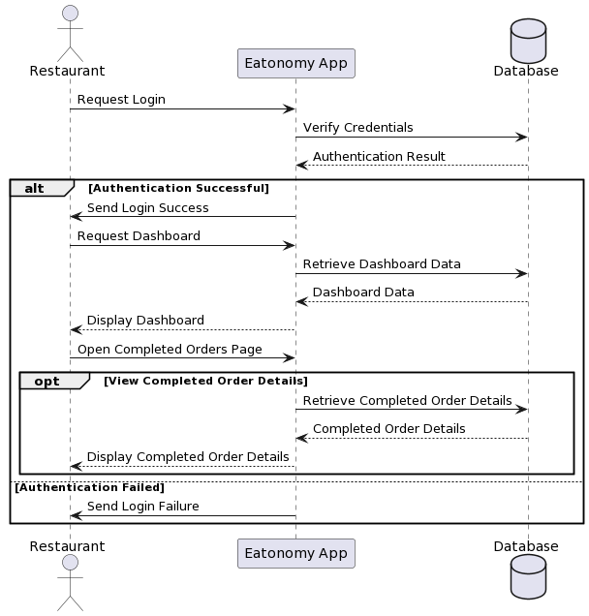

###### *Figure 8.17 Sequence Diagram Restaurant Completed Orders*

##### 4.6.18 Sequence diagram for Restaurant Refunds

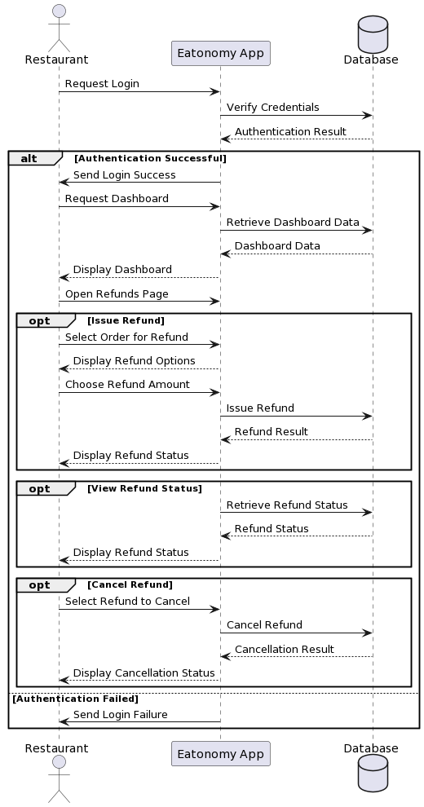

###### *Figure 8.18 Sequence Diagram Restaurant Refunds*

#### Collaboration Diagram

It shows the object organization as shown below.

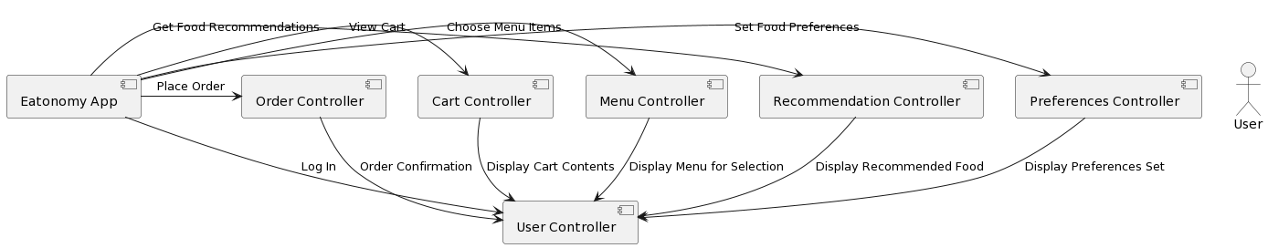

###### *Figure 9 Collaboration Diagram*

#### State Transition Diagram

State Transition diagram is used to describe the states of different objects in its life cycle. So, the emphasis is given on the state changes upon some internal or external events. These states of objects are important to analyze and implement them accurately

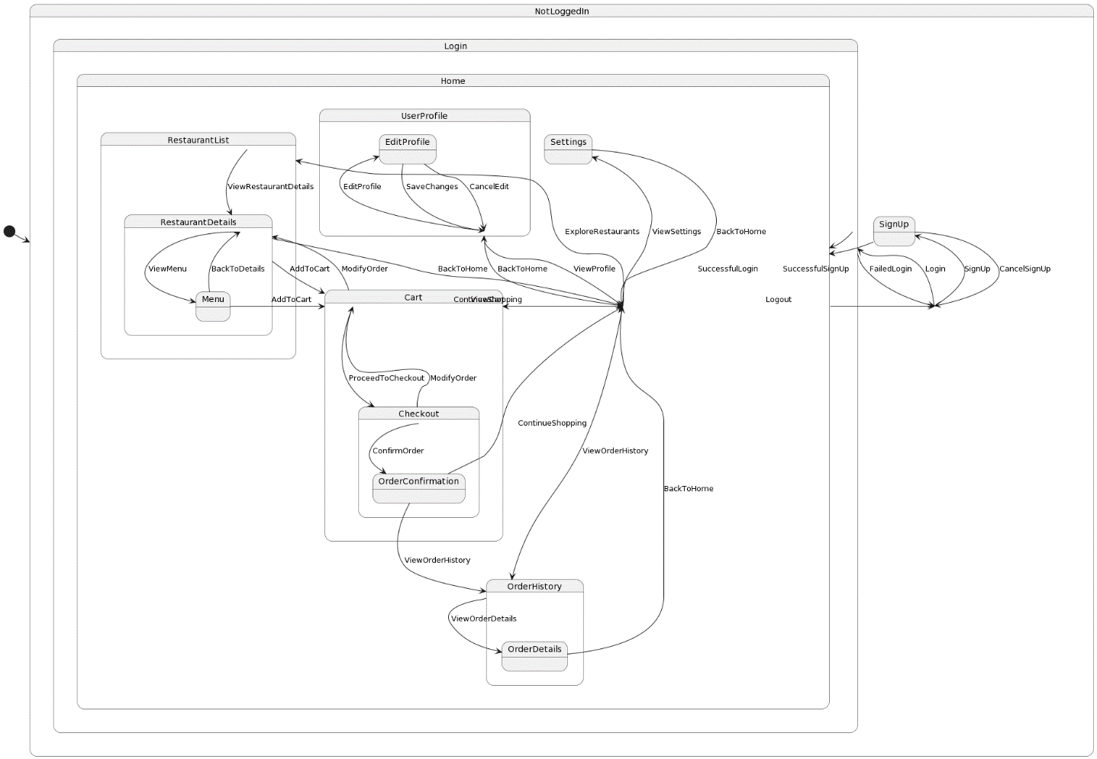

###### *Figure 10 State Transition Diagram*

#### Component Diagram

Component diagrams are used to describe the physical artifacts of a system. This artifact includes files, executables, libraries etc.

So, the purpose of this diagram is different, Component diagrams are used during the implementation phase of an application. But it is prepared well in advance to visualize the implementation details.

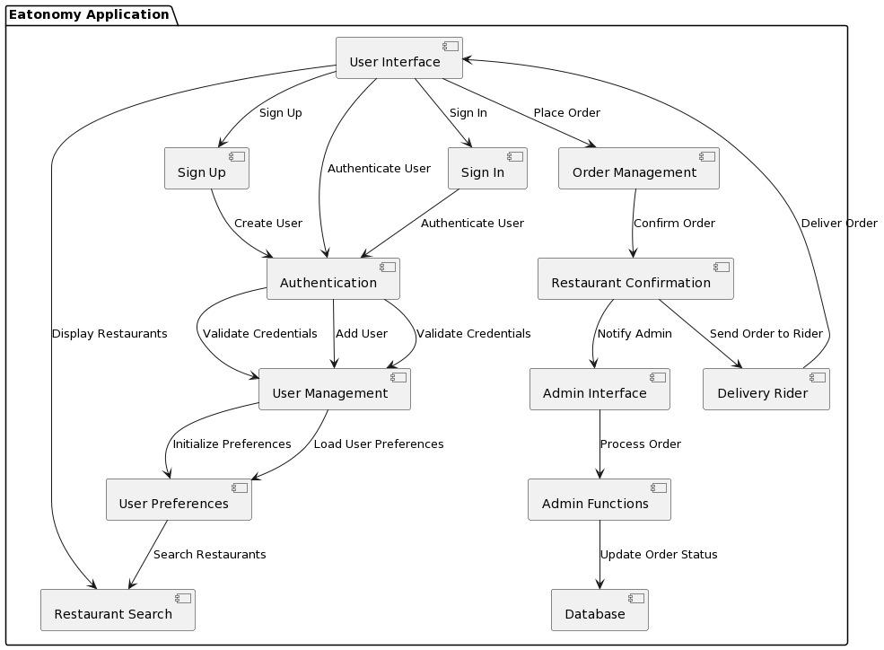

###### *Figure 11 Component Diagram*

#### Deployment Diagram

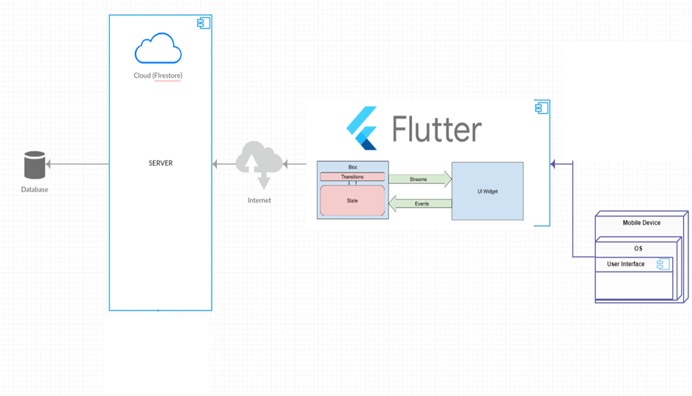

###### *Figure 12 Deployment Diagram*

# Chapter 5: Testing

#### Test Case Specifications

This Testing phase includes all the Test Cases of the functional requirements of your project

For example, your login account test case looks like this and you have to follow this template for writing your project test cases

Test Case for login account

|  |  |  |
| --- | --- | --- |
|  | Positive Test Case | |
| ID | TC_LOGIN_SUCCESS | |
| Priority | High | |
| Description | To verify user authentication to system. | |
| Reference | Functional Requirement reference | |
| Users | Administrator. | |
| Pre-requisites | A | System is online. |
|  | B | User must have active login credentials provided by system administrator. |
|  | C | User has internet access. |
| Steps | A | Open the web link to system. |
|  | B | Enter login id |
|  | C | Enter Password. |
|  | D | Press Login. |
| Input | Login id and password | |
| Expected result | Successfully enters the system and main home page opens. | |
| Status | Tested, passed. | |

##### *Table 3.1: Positive Test Case – Login*

|  |  |  |
| --- | --- | --- |
|  | Negative Test Case | |
| ID | TC_LOGIN_FAILURE | |
| Priority | High | |
| Description | To verify user authentication to system. | |
| Reference | Functional Requirement reference | |
| Users | Administrator. | |
| Pre-requisites | A | System is online. |
|  | B | User must have active login credentials provided by system administrator. |
|  | C | User has internet access. |
| Steps | A | Open the web link to system. |
|  | B | Enter login id. |
|  | C | Enter Password. |
|  | D | Press Login. |
| Input | Incorrect Login id or password or deactivated credentials. | |
| Expected result | Does not allows access to system features and notifies the error. | |
| Status | Tested, passed. | |

Table 4 Negative Test Case

#### Black Box Test Cases

Black box testing also known as Behavioral Testing, is a [software testing method](http://softwaretestingfundamentals.com/software-testing-methods/) in which the internal structure/ design/ implementation of the item being tested is not known to the tester. These tests can be functional or non-functional, though usually functional.

This method is named so because the software program, in the eyes of the tester, is like a black box; inside which one cannot see. This method attempts to find errors in the following categories:

* Incorrect or missing functions
* Interface errors
* Errors in data structures or external database access
* Behavior or performance errors
* Initialization and termination errors

* + 1. **Equivalence Partitions (EP)**

Equivalence class partitioning (EP) is a very widely used method to decrease the number of possible test cases that are required to test a system.

Let see the example of Equivalence Partitions for login Authentication

|  |  |  |  |
| --- | --- | --- | --- |
| **Variables** | **Valid Classes** | | **Invalid Classes** |
| Username | 1. 2.  3. | Only username “admin”.  Case in-sensitive.  Compulsory field. | 1. Alphabets, digits and symbols other than “admin”. 2. Empty Field. |
| Password | 1.  2. | Length should be greater than 5 characters.  May contain symbols, alphabets [a-z A-Z] and digits [0-9]. | 1. Length less than 5 characters. 2. Empty field. |

Table 5 Valid Classes and Invalid Classes

* + 1. **Boundary Value Analysis**

A boundary value is an input or output value on the border of an equivalence partition, includes minimum and maximum values at inside and outside boundaries. Normally Boundary value analysis is part of stress and negative testing.

* + 1. **Decision Table Testing**

Decision Table is a testing method, which aims to ensure that each one of the possible branch from each decision point is executed at least once and thereby ensuring that all reachable code is executed.

* + 1. **State transition Testing**

State Transition testing, a black box testing technique, in which outputs are triggered by changes to the input conditions or changes to 'state' of the system. In other words, tests are designed to execute valid and invalid state transitions.

* + 1. **Use Case Testing**

Use Case Testing is a functional black box testing technique that helps testers to identify test scenarios that exercise the whole system on each transaction basis from start to finish.

#### White Box Test Cases

White box testing is a testing technique, that examines the program structure and derives test data from the program logic/code. The other names of glass box testing are clear box testing, open box testing, logic driven testing or path driven testing or structural testing.

* + 1. **Cyclometric complexity**

Cyclometric complexity is a source code complexity measurement that is being correlated to a number of coding errors. It is calculated by developing a Control Flow Graph of the code that measures the number of linearly-independent paths through a program module.

Lower the Program's cyclometric complexity, lower the risk to modify and easier to understand.

#### Performance testing

Performance testing, a non-functional testing technique performed to determine the system parameters in terms of responsiveness and stability under various workload. Performance testing measures the quality attributes of the system, such as scalability, reliability and resource usage.

#### Stress Testing

Stress testing a Non-Functional testing technique that is performed as part of performance testing. During stress testing, the system is monitored after subjecting the system to overload to ensure that the system can sustain the stress.

The recovery of the system from such phase (after stress) is very critical as it is highly likely to happen in production environment.

#### System Testing

System Testing (ST) is a black box testing technique performed to evaluate the complete system the system's compliance against specified requirements. In System testing, the functionalities of the system are tested from an end-to-end perspective.

System Testing is usually carried out by a team that is independent of the development team in order to measure the quality of the system unbiased. It includes both functional and NonFunctional testing.

#### Regression Testing

Regression testing a black box testing technique that consists of re-executing those tests that are impacted by the code changes. These tests should be executed as often as possible throughout the software development life cycle. Types of Regression Tests:

Final Regression Tests

A "final regression testing" is performed to validate the build that hasn't changed for a period of time. This build is deployed or shipped to customers.

Regression Tests

A normal regression testing is performed to verify if the build has NOT broken any other parts of the application by the recent code changes for defect fixing or for enhancement.

* + 1. **Selecting Regression Tests**
* Requires knowledge about the system and how it affects by the existing functionalities.
* Tests are selected based on the area of frequent defects.
* Tests are selected to include the area, which has undergone code changes many a times.
* Tests are selected based on the criticality of the features.
  + 1. **Regression Testing Steps**

Regression tests are the ideal cases of automation which results in better **R**eturn **on** **I**nvestment (ROI).

* Select the Tests for Regression.
* Choose the apt tool and automate the Regression Tests
* Verify applications with Checkpoints
* Manage Regression Tests/update when required
* Schedule the tests
* Integrate with the builds
* Analyze the results

# Chapter 6: Tools and Techniques

This chapter includes the following

* Languages you are using in the development
* Applications and tools
* Libraries and Extensions if any

# Chapter 7: Summary and Conclusion

This chapter include the summary and the conclusion

# Chapter 8: User Manual

##### 8.1 Sign Up Screen

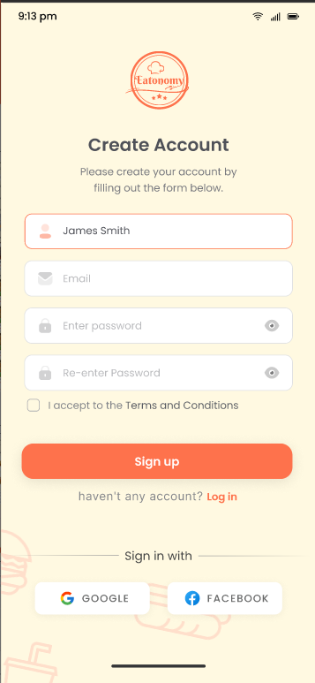

###### *Figure 13.1 Login Screen*

The Signup screen facilitates a streamlined account creation process for users utilizing their email addresses. Designed with a focus on user-friendly interaction, it features intuitive text fields for personal information, a secure password creation mechanism, and a prominent Signup button. The interface prioritizes simplicity, efficiency, and clear guidance, ensuring a smooth onboarding experience. Robust error handling enhances reliability, guaranteeing a seamless account creation journey.

##### 

##### 8.2 Log in Interface

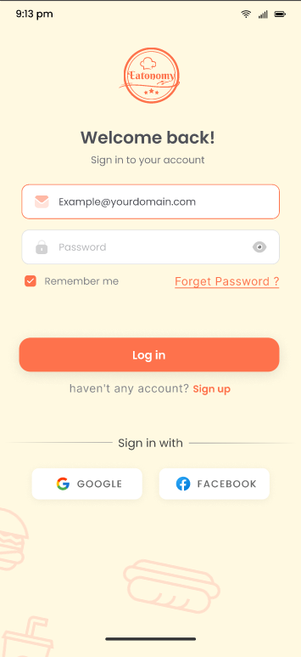

###### *Figure 13.2 Sign up Screen*

The Login screen offers users a versatile authentication experience, providing the option to log in directly through Google or via email credentials. The interface is designed for efficiency and simplicity, featuring dedicated fields for email and password entry for those choosing traditional login. Simultaneously, users opting for Google login benefit from a swift and secure authentication process. With a focus on user-friendly design, clear instructions, and robust error handling, the Login screen ensures a seamless and reliable access point, prioritizing a positive user experience.

##### 8.3 Preferences Hub

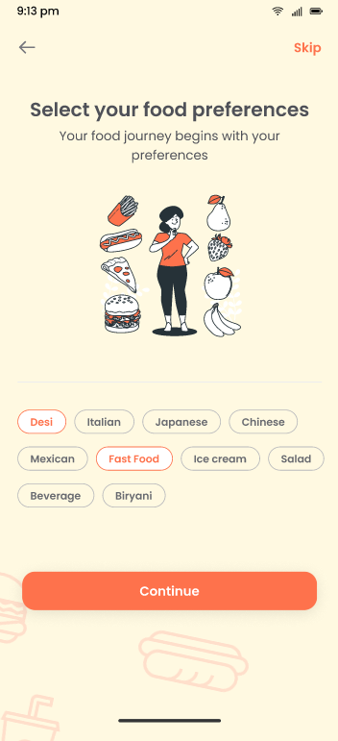

###### *Figure 13.3 Preferences Screen*

The Preferences Screen serves as a refined gateway to personalized dining experiences. Here, users articulate their culinary preferences, enabling our system to discern and recommend suitable restaurants. Through a seamless process, users specify desired cuisines and ambiance criteria, allowing the screen to curate a tailored list of establishments. This user-centric approach ensures a gratifying dining journey, where each restaurant suggestion resonates with the unique tastes and preferences of the individual. The Preferences Screen embodies our commitment to delivering a sophisticated and personalized dining exploration for every user.

##### 8.4 Eatonomy Hub

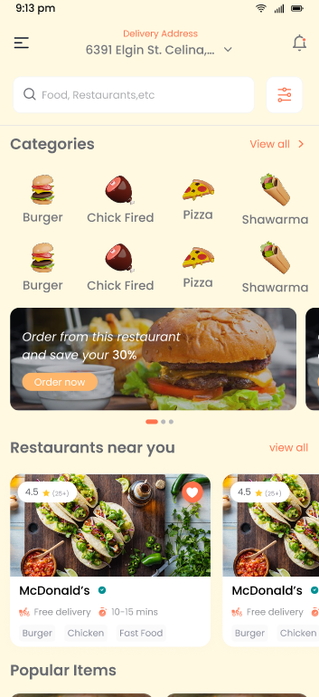

###### *Figure 13.4 Eatonomy Hub*

Welcome to the heart of Eatonomy – the Eatonomy Hub. As your home screen, it unveils a feast of possibilities, presenting diverse food categories tailored to your tastes. Engage with your preferred restaurants, seamlessly carried over from your personalized selections. Delve into the culinary tapestry with curated highlights, showcasing the most popular offerings from these cherished establishments. Feel the power at your fingertips as you search for specific delicacies, customizing your gastronomic adventure. Not only that, but Eatonomy Hub also connects you with nearby restaurants, ensuring you're always a step away from discovering new flavors. Explore, savor, and enjoy the seamless synergy of your culinary journey with Eatonomy.

##### 8.5 Restaurant Profile

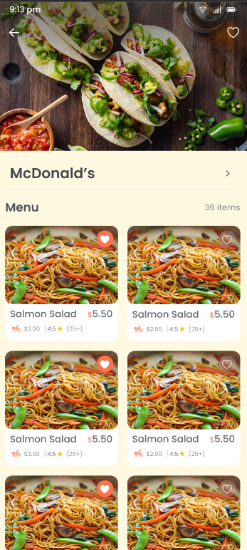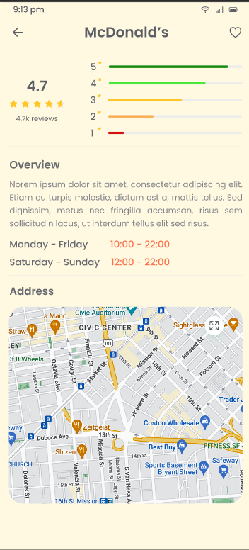

###### *Figure 13.5 Restaurant Overview*

Welcome to the Restaurant Overview screen, a curated space delivering essential details at a glance. The restaurant's name takes center stage, guiding your culinary exploration. Ratings and user comments provide insights into the dining experience, offering a snapshot of the establishment's reputation. The location details are presented clearly, accompanied by the precise address, ensuring seamless navigation. This concise and informative layout on the Restaurant Overview screen is tailored to empower users with the key information needed to make informed and satisfying dining choices.

##### 8.6 View Cart

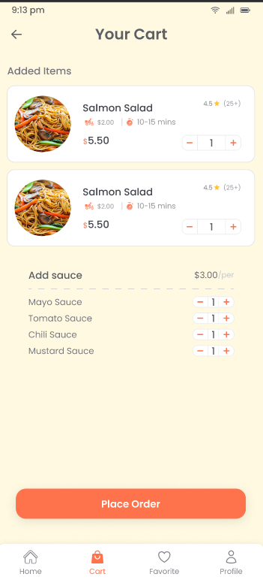

###### *Figure 13.6 View Cart*

The View Cart screen is where your culinary choices come together effortlessly. Here, users can easily review and place orders for their selected items. Simple controls enable quick quantity adjustments, ensuring a personalized dining experience. Customize your order to perfection by adding extra sauces through the user-friendly interface. The View Cart embodies efficiency and convenience, making the final step of the ordering process as seamless and delightful as the culinary journey itself.

##### 8.7 Favorites Hub

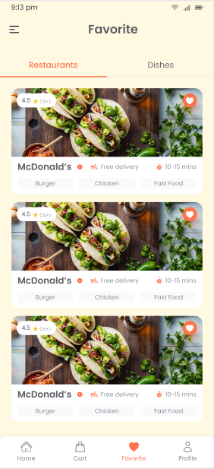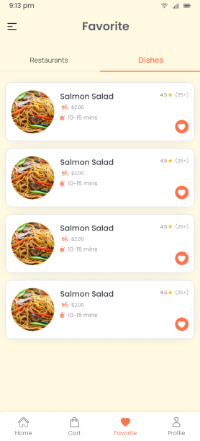

###### *Figure 13.7 Favorites Hub*

Step into the Beloved Picks screen, a curated space where your culinary preferences take center stage. Here, users can easily navigate through their favorite restaurants and cherished food items, simplifying the process of placing orders. This feature serves as a personalized shortcut, allowing users to directly connect with their favored dining experiences. The Beloved Picks screen encapsulates user-centric convenience, offering a seamless and efficient way to indulge in the flavors that resonate most with each individual. Enjoy the ease of direct access to your culinary favorites with Beloved Picks.

# References

# 

The references shall be quoted in the following format as provided by IEEE:

**Websites**

[Ref number] Author’s initials. Authors Surname. (Year, Month. Day). Title of web page [Online]. Available: URL

1. Flutter. (n.d.). Flutter[Online]. Available: <https://flutter.dev/>
2. Lucidchart. (n.d.). Lucidchart [Online]. Available: <https://lucid.app/>
3. PlantUML. (n.d.). PlantUML [Online]. Available: <http://www.plantuml.com/>
4. Figma. (n.d.). Figma [Online]. Available: <https://www.figma.com/>
5. Firebase. (n.d.). Firebase [Online]. Available:<https://firebase.google.com/>

# Appendix

* A section at the end of a document that includes information that is too detailed for the text of the document itself and would "burden the reader" or be "distracting," or "inappropriate" (APA, 2010, p. 38-9).
* The content in the appendices should be "easily presented in print format" (APA, 2010, p. 39).
  + Examples:
    - lists of length (short lists belong in the document itself)
    - detailed descriptions (essential details should be in the document itself)
    - a list of articles that support data but are not referred to in the document itself
    - demographic details for subpopulations studied by the document

